**CMDR Clicker’s**

**Elite Dangerous Target Script**

**User Reference Guide**

**(v5.0.2 - Odyssey)**

Contents

Introduction 3

Acknowledgements and credits 4

Script Package Contents 5

Installation 6

Features 7

Usage 9

Elite Dangerous Configuration 12

MapKey Profiles 13

Training Mode 14

Modifiers 15

Axis Curves and Curve Control 17

Joystick Controller 23

Throttle Control Lever 40

Throttle Control Base 49

TFRP Rudder Controller 61

Keyboard Key Binds 62

ED_UserSettings File 64

Joystick Map - FULL 66

Throttle Map - FULL 67

Joystick Map – BASIC 68

Throttle Map – BASIC 69

Keyboard Utilisation 70

Key Bind Sheet – In Ship/SRV/Fighter 71

Key Bind Sheet – On Foot 72

HOTAS Switch and Button Reference – FULL 73

HOTAS Switch and Button Reference – BASIC 74

Disclaimer 75

# Introduction

PURPOSE: This document describes what my script includes, what it does, how to install and configure.   
It is also meant as a reference for what the switches, buttons and axes do when my script is running.

My script package has been written for a dual purpose.   
First, to enhance immersion and control within the game of Elite Dangerous.   
Secondly, is to provide [TARGET](http://www.thrustmaster.com/node/4730) Script code examples to complement and extend beyond what is covered in the [Fast Script Basics User Manual](https://ts.thrustmaster.com/download/accessories/pc/hotas/software/TARGET/TARGET_Script_Editor_Basics_v1.5_ENG.pdf) provided by Thrustmaster.

HISTORY: Inspiration for this script started with [Aussiedoid’s comprehensive Elite Dangerous script](https://forums.frontier.co.uk/threads/aussiedroids-enhanced-thrustmaster-warthog-script.293027/) (v3.1.0). I then created my own script to mimic my old Saitek X-55 basic configuration. I have since learned and used the advanced abilities of TARGET Script to create a "smart" configuration and have studied and lifted ideas and methods from Aussiedroid and others including Elite Dangerous Forum members, CMDRs Touille, Darkcyde and others.

PHILOSOPHY: Whilst convenient, I tend not to use the [HOTAS](https://en.wikipedia.org/wiki/HOTAS) for non-HOTAS functions (eg I do not currently issue chat macros or fighter instructions etc via TARGET).

I've written the functions to suit my preferences, my play style and my hardware, however I have made a few concessions here to cater to users who may not use headlook via Opentrack or rudder pedals.

My HARDWARE: The script and supporting files are written and maintained to work with my current hardware setup. This includes a [Thrustmaster Warthog HOTAS](https://shop.thrustmaster.com/en_gb/products-joysticks/hotas-warthogtm.html), [Thrustmaster TFRP Pedals](https://shop.thrustmaster.com/en_gb/products-joysticks/t-flight-rudder-pedals.html) and [Webcam via Opentrack](https://github.com/opentrack/opentrack/releases). Keyboard and mouse usage is limited to only a few functions when flying or in SRV and solely used as input when on foot.

I have supplied a ‘full” [bind file](https://support.frontier.co.uk/kb/faq.php?id=465) which will work with or without the pedals. These bindings should just work ‘out of the box’.

COMPATIBILITY: This script has been designed and tested to work with Elite Dangerous Horizons & Odyssey on Windows 10.   
  
The script requires TARGET software v3.0.24.618_rev1, Joystick firmware v12 and Throttle firmware v23.  
   
The console output is formatted for the GUI, so be careful changing the printf() formatting when using the editor as the GUI and editor use different fonts etc.

NOTE: The script uses extensive game state tracking via the [status.json](http://hosting.zaonce.net/community/journal/v28/Journal_Manual_v28.pdf) journal file which is created and updated whilst the game is running. If this file becomes unreadable or unavailable, the script will abort.

I hope you enjoy this script and that it suits your requirements and playstyle. I look forward to any feedback and suggestions you may have for improvement.

Fly dangerously commanders!

[CMDR Clicker](https://forums.frontier.co.uk/members/clicker.19039/) o7

# Acknowledgements and credits

Elite Dangerous is a copyright of Frontier Developments plc

T.A.R.G.E.T. and Thrustmaster are copyrights of Guillemot Corporation S.A.

[Fast Script Basics User Manual by Thrustmaster](https://ts.thrustmaster.com/download/accessories/pc/hotas/software/TARGET/TARGET_Script_Editor_Basics_v1.5_ENG.pdf)

Original script inspiration and functionality by Aussiedroid.

<https://forums.frontier.co.uk/members/aussiedroid.21601/>

<https://forums.frontier.co.uk/threads/aussiedroids-enhanced-thrustmaster-warthog-script.293027/>

<https://github.com/Aussiedroid/AD-EDWarthogEnhancedScript>

Contribution and ideas lifted from Touille and Darkcyde.

<https://forums.frontier.co.uk/members/cmdr-touille.110127/>

<https://github.com/Touille/ED-Warthog-Target-Script>

<https://forums.frontier.co.uk/members/darkcyde.26482/>

Analogue Slew Controller hardware upgrade – get rid of that crappy ‘mouse nub’ on the Throttle!

<https://deltasimelectronics.com/products/thumbstick-slew-sensor-adapter>

Last but not least, a lot of my learning came from assistance, directly or indirectly by several key people in particular;

On HOTAS/HOSAS/SIMPIT Discord (<https://discord.gg/szqaJE7>) …

@sYfte

@hon0

@dar|{cyde

Over on DCS World forums (<https://forums.eagle.ru/>) …

@ivanwfr <https://forums.eagle.ru/member.php?u=82172>

@Sgt Coyle <https://forums.eagle.ru/member.php?u=88210>

@Drakoz <https://forums.eagle.ru/member.php?u=108387>

Elite Dangerous Journal Guide

<http://hosting.zaonce.net/community/journal/v37/Journal_Manual_v37.pdf>

# Script Package Contents

When publishing or sharing this script the following should be included in the zipped package;

* The readme file
* The license file
* This reference manual
* Script code files (*.tmc, *.tmh, *.ttm)
* Voice.exe (users can find this on github and check out the source if they wish)
* sounder.exe (users can find this on github via the same author as voice.exe)
* sample wav files used by the script
* TTS Voice registry scraps to assist with installing extra Microsoft Voices
* Windows batch file (SAMPLE_Launcher.cmd) to use to launch Elite Dangerous, my TARGET script and supporting apps)
* The Elite Dangerous .bind files created to support this script
* The image files created to summarise the Joystick and Throttle button assignments
* The image files created to summarise keyboard key utilisation
* The change log for this version

# Installation

* 1. Copy the preferred .bind file in the package's 'Bindings' folder to your Elite Dangerous bind file folder. This is usually at …  
     "c:\users\%username%\AppData\Local\Frontier Developments\Elite Dangerous\Options \Bindings"

As 'AppData' can usually be hidden you may need to unhide it via the folder view options in Windows if navigating via the windows explorer. Or, you should be able to cut/paste/edit the path above into a run box or address bar

NOTE: You should use the bind file in Bindings\Full folder within the zip package even if you don’t have a TFRP Pedal controller

* 1. Unzip the script files anywhere on your disk that you can easily find/get to  
     Example used in this document is c:\Thrustmaster\ED_TargetScript   
     Substitute this with your path (within this doc) if you decide to save to somewhere else.
  2. Copy voice.exe and sounder to c:\Thrustmaster\ED_TargetScript\ and set correct path in the ED_UserSettings.tmh file for both VoicePath and VoiceCMD variables
  3. Copy Sounds folder to c:\Thrustmaster\ED_TargetScript\sounds\ and set correct path in ED_UserSettings file
  4. Print out and study the image files provided in the 'Maps' folder.
  5. Before you run the script open the ED_UserSettings.tmh file in notepad (I recommend using Notepad++) and ensure;
     + the path definitions for ‘StatusFile’, ‘MyStatusFile’, ‘VoicePath’ , ‘SoundPath’ and ‘WAVPath’ are all correct
     + Set ‘DefaultVoice’ to a Microsoft TTS voice installed on your PC  
       (enter “voice –l” at a cmd prompt where you copied voice.exe to list available TTS voices)
     + Set ‘VoiceCMD’ to include your preferred voice.exe command line switches
     + Set ‘EnableTFRPRudder’ to = 0 if you do not have this rudder controller
  6. The Preferred method of running the script is via a Windows batch file.  
     SAMPLE_Launcher.cmd batch file is included in this package and is best copied to wherever you copied the scripts to in "step b" above.  
     I recommend you create a shortcut to this batch file on your desktop and run it as administrator. Please read the comments in this batch file for more information
  7. The script MUST be running before you start the game.
  8. When you run the game for the first time, go to Options | Controls and select the .bind file profile included in the zip package. (example: "Clicker-Warthog-v501")
  9. If you do not have a TFRP Rudder controller you will need to correct the bindings for the following in game functions;
     + Ship yaw
     + [SRV](https://elite-dangerous.fandom.com/wiki/Scarab) Steering
     + Camera yaw, [FSS](https://elite-dangerous.fandom.com/wiki/Full_Spectrum_System_Scanner) Camera yaw & SAA ([DSS](https://elite-dangerous.fandom.com/wiki/Detailed_Surface_Scanner)) Third-Person yaw

# Features

* Automatic detection of compatible Thrustmaster joystick bases, flight sticks, rudders and throttles;
  + Warthog base with F16 or F18 flight stick
  + AVA base with F16 or F18 flight stick
  + Warthog Throttle
  + TFRP or TFRPHA rudder pedals.
* 2 separate, user selectable MapKey profiles
  + FULL – all the bells and whistles
  + BASIC – no macros, no function calls, just send basic keystrokes
* 3 additional firing modes for primary and secondary triggers including
  + [Pulse Wave Scanner](https://elite-dangerous.fandom.com/wiki/Pulse_Wave_Analyser) mode (fires a pulse every 7 seconds)
  + [Discovery Scanner](https://elite-dangerous.fandom.com/wiki/Discovery_Scanner) mode (holds trigger for 6.1 seconds)
  + [Mining Laser](https://elite-dangerous.fandom.com/wiki/Mining_Laser) Mode (press to fire, press to stop)
* 5 user customisable, change on the fly, curve profiles for Joystick, Rudder and Slew selectable via the autopilot switch
* [FA-OFF](https://elite-dangerous.fandom.com/wiki/Flight_Assist) automatically applies custom curves to joystick and rudder
* User customisable curve profiles for slew control and slider
* Slider curves (Radar tuning) automatically applied via flight mode tracking
* Advanced PIP Manager includes 6 PIP modes, all selectable on the fly
* Advanced Counter measures control includes single [SCB](https://elite-dangerous.fandom.com/wiki/Shield_Cell_Bank), SCB with auto [heatsink](https://elite-dangerous.fandom.com/wiki/Heatsink_Launcher) and ‘Double Bank’ (2 x SCB + 1x heatsink) modes
* Silent Running ‘Strobe’ feature to toggle silent running on/off every 2 seconds
* Text-To-Speech engine provides additional voice feedback
  + turn on/off on the fly
  + volume control on the fly
  + includes a training mode which speaks each switch/button function
  + user selectable default voice
  + use different voices for different functions (in script only)
* Sound effects engine to add extra feedback in game
* Advanced state processor, which reads status.json twice per second and detects when key flags are changed.
* Additional flags tracked, saved to file and loaded when required, automatically
* Comprehensive print to console messages by most functions
* On the fly LED ON/OFF plus brightness control.
* Status LEDs accurately synchronised with game states for 5 key ship systems
* Flashing base LEDs on game start and flashing status LEDs on state change
* User Setting to enable or disable flashing LEDs
* Accurate game start and stop detection
* Macros included for;
  + Docking request with auto PIPs to shields
  + [Wing Beacon](https://elite-dangerous.fandom.com/wiki/Wings) On/Off
  + [Report Crimes](https://elite-dangerous.fandom.com/wiki/HUD/Right) On/Off
  + Deploy and Recover the SRV
  + Dismiss/Recall Ship
  + [Station services](https://elite-dangerous.fandom.com/wiki/Station) which can be set to auto on dock, or via switch
  + Launch+lift off+retract landing gear+25% throttle
  + Fast Game Mode switching (includes [anti-clog](https://elite-dangerous.fandom.com/wiki/Combat_Logging) code)
* Simple, logical target designator functions including system module targeting
* Speed brake function using timed landing gear deployment/retraction
* Advanced Super cruise / Hyper jump tracking with drop detection

(…features continued)

* Joystick, Throttle and Keyboard Utilisation images for both BASIC and FULL profiles
* Fully documented and commented code
* Comprehensive Key Bind Sheet file detailing standard and combo keyboard keys
* Toggle Engine and Weapon colours on the fly
* 2x comprehensive custom key bind files included
* Extensive use of layers using Throttle Pinky and/or Joystick Pinky switches
* Audio reminders when Throttle Pinky modifier switch is not in the middle
* Training Mode which prints to console and speaks the function of all buttons and switches
* Registry Scraps to add extra TTS voices
* On the fly swapover of YAW and ROLL
* Huge amount of code cleanup, bug fixes and improvements
* ...and more!

# Usage

All user configurable settings are in the ED_UserSettings.tmh file.

Avoid changing anything in ED_GlobalVars.tmh or ED_Defines.ttm files.

Feel free to use the ideas and methods for your own use in your own scripts and I encourage you to share these with other like-minded players.

This software uses the [MIT license](https://opensource.org/licenses/MIT), which can be found at the root of this package/repository.

**Intent**

Most buttons and switches ‘do something’ other than just send a simple keystroke or a [Direct-X](https://en.wikipedia.org/wiki/DirectX#DirectX_12) (DX#) button or axis value to the game.

Likewise, most of the axes available have different profiles (behaviours) depending on a user setting, a specific combination of button presses, or, indeed one of many game states (written to status.json).

This guide is intended to describe what each button/switch does and how the different Joystick, Throttle, slider and Slew Control (mini stick) axes behave depending on situation or user definable configuration and in game actions.

This document is not intended to teach TARGET Script or walk you through my code. I will try to keep the scripting (code) description to an absolute minimum. Saying that, the script itself provides an excellent resource providing many comments that can help you if you wish to learn TARGET Script, or modify mine to suit your needs.

**Console**

The script will output to the Target Script GUI console the result of many commands. Whilst not required to play the game, you can use this feature to ensure you are hitting the correct switch/button or sequence.

Likewise, the script will output error messages to the console and speech engine when you select an invalid button. Example: trying to lower the landing gear when in super cruise

(…Usage continued)

**Text-To-Speech (TTS)**

I have included a voice feedback feature that uses a Text-To-Speech engine and Microsoft’s Voice capability to add more immersion and feedback when you select certain actions.

Many of the console messages are also converted to speech.

For this to work, copy **voice.exe** to your script folder and correctly set the path inside the ED_UserSettings.tmh file.

The volume for the Text-To-Speech function can be changed on the fly and the feature can be turned off completely using specific HOTAS switch combinations.

Refer to the individual switch references in the below chapters for more detail.

This Text-To-Speech feature is usually straight forward…assuming Microsoft Speech services are enabled and you have at least one language pack installed (which you do, believe me!)

It can get a bit tricky … **IF** … you wish to use a voice not already installed on your PC.  
More on that later.

I would suggest you first run voice.exe from the command line as follows:-

1. Open a command prompt at your script folder location
2. Type in ‘voice -l’ (lower case ‘L’) and hit enter

This will list any/all installed and available Microsoft TTS Voices installed on your PC.

If the list is empty, it means you do not have Microsoft Text To Speech feature enabled…refer to section below on customising voices.

Assuming you do have at least one voice installed you can test by typing in **voice “Hello”** and hit enter. This will say the text in the quotes using your PC’s default voice.

Assuming the test above went well, let’s open ED_UserSettings.tmh and go to the ‘Text To Speech’ section.

1. Make sure ‘EnableVoice’ is set to 1 (or ‘ENABLED’)
2. Make sure the ‘VoicePath’ alias is correct
3. Make sure there is an alias for the voices installed in your PC (plenty of examples listed)
4. Set ‘DefaultVoice’ to one of the installed aliases

Example: if the list you got shows ‘Hazel’, go ahead and set ‘DefaultVoice = &Hazel;’

All going well, ‘Hazel’ will greet you when the game starts.

If you wish to use non-standard or not-installed voices here is a very basic rundown on what you need to do.

(…Usage – Text-To-Speech … continued)

First, open ‘Speech Settings’ on your PC, select ‘Language’, then under ‘Preferred Languages” add whichever languages you want to take advantage of.

Next, when prompted to confirm which features to install….make sure “speech” is enabled and go ahead and install.

Now, for the fun part (sic)…

By default, Microsoft Windows 10 does not enable all language voices to be accessible to all applications.

So, after installing the pack and restarting your PC, check if the TTS Voice is available via **‘voice –l’**…if your new TTS voice shows up, you are good to go…if it does not show up in the list, follow this web based tutorial for those voices you wish to make available to voice.exe…

<https://www.ghacks.net/2018/08/11/unlock-all-windows-10-tts-voices-system-wide-to-get-more-of-them/>

…it looks complicated at first, but is actually pretty simple…just take your time and in no time you’ll unlock the voice you want to use with this script.

Do not forget to go back, create an alias for the voice, and set ‘DefaultVoice’ accordingly.

This version of my script only uses one voice. I have included the ability to use different or multiple voices for future planned functionality.

If you head over to the Elite Dangerous forums and send me a PM asking nicely, I’ll happily send you a copy of the reg scraps for any of the voices I list in my code!

# Elite Dangerous Configuration

Additional configuration items I have set in game;  
  
Options | Controls  
(included in the bind files – here as a short reference for note)

* Throttle Axis Range = Forward Only
* Fwd Only Throttle Reverse Button Mode = Toggle
* Flight assist button mode = Toggle
* Rotational Correction = Toggle
* Firing Deploys Hard points = OFF
* Silent Running Button Mode = Toggle
* Cargo Scoop Button Mode = Toggle
* Microphone Mute Button Mode = Toggle
* Mute Button Mode = Toggle
* Microphone State Mode = Toggle
* Enable Context Menu = OFF
* UI Focus Mode = Cycle
* Autofocus on Text Input = OFF
* Looking at * Panel = Does Nothing
* Show CQC Score Screen Button Mode = Toggle
* Head look Button Mode = Toggle
* Centre when Head look Inactive = ON
* Head look Smoothing = ON
* Drive Assist Button Mode = Toggle
* Handbrake Button Mode = Toggle
* Drive Throttle Axis Range = Forward Only
* Drive Throttle Reverse Button Mode = Toggle
* Free Camera Throttle Axis Range = Forward Only
* DSS Front/Back Button Mode = Toggle

Options | Sound | Voice Volume | Ship Voice Volume (all ‘ON’ unless stated below)

* Power & Temperature
  + Silent Running Engaged = OFF
  + Silent Running Disengaged = OFF
* Landing & Docking
  + Landing Gear Deployed = OFF
  + Landing Gear Retracted = OFF

# MapKey Profiles

There are two MapKey Profiles to choose from, FULL and BASIC, selectable in the ED_UserSettings file.

The **BASIC profile**, maps straight keyboard keypresses to the triggers, switches and buttons.

No macros, functions or modifiers are available in this profile so most of the features of the script are simply bypassed. This profile is for players looking for a straight WARTHOG profile and binding file combination, or players who are just starting out and want a simpler solution. The bind files, installation instructions etc are all compatible for both modes.

The **FULL profile** takes advantage of every feature, macro and function. It also has some rudimentary debug features, which can come in handy when you are not certain things are quite right.

Refer to **ED_UserSettings File** chapter, later in this guide.

# Training Mode

When the game is not running, pressing any of the buttons or switch combinations described in the following chapters will result in both Voice feedback and a console printout of the mapped function. Make sure you also check out the modified buttons and switches!

The training mode is customised for both FULL and BASIC profiles.

Enable ‘TrainingEnabled’ in the ED_UserSettings file to take advantage of this training mode.

Enable ‘AnnounceTraining’ in ED_UserSettings file to announce via Voice feedback the selected Training mode status when the script starts or when the games stops.

# Modifiers

The ‘FULL Profile’ uses modifiers which do much the same thing as the ‘SHIFT’ or ‘ CTRL’ keys do on a keyboard…they change or extend the use of the switch or button on the HOTAS.

Using modifiers, each button or switch can have up to six different functions.

It is worth noting that I do not use modifiers on all switches and buttons … only about half of the buttons available are mapped to use modifiers.

The modifiers use the designations I, O, U, M, D. The letters stand for ‘In’, ‘Out’, ‘Up’, ‘Middle’ and ‘Down’

The script uses the Joystick S3 (‘Nose wheel’) button as the IO modifier. When pressed we are using the ‘I’ layer. ‘O’ layer is being used when it isn’t pressed.

The script uses the Throttle PSF, PSM, PSB (‘Pinky Switch’) as the UMD modifier (layers). PSF is the ‘U’ layer, PSM is the ‘M’ layer and PSB is the ‘D’ layer (F=Forward, M=Middle, B=Back)

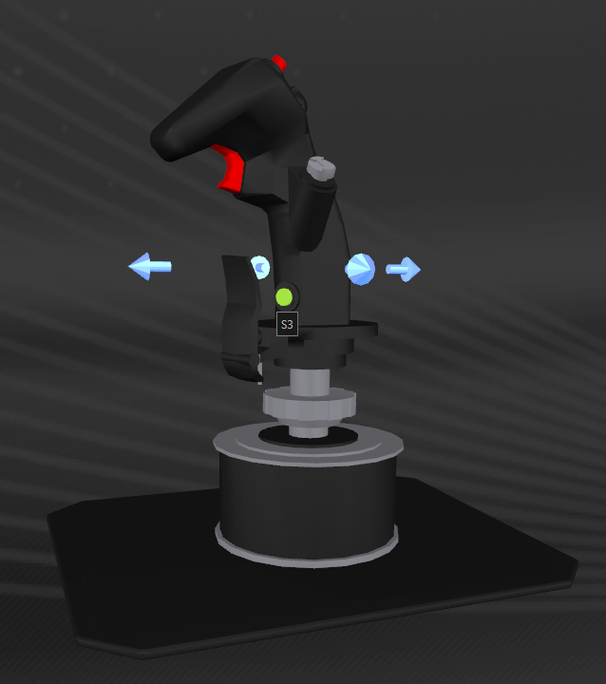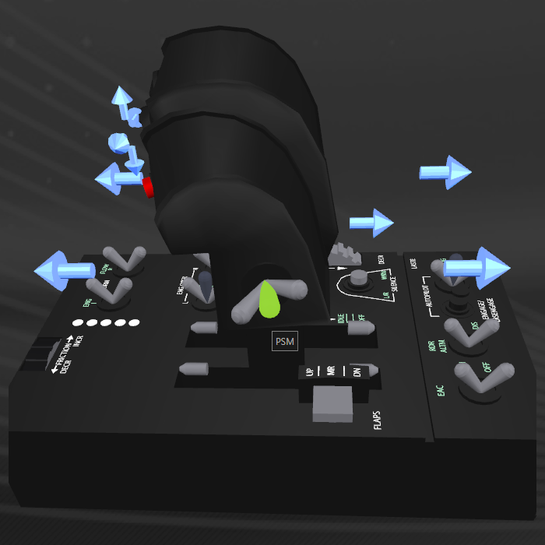  
 Joystick S3 ‘Nosewheel’ switch Throttle PSF/PSM/PSB ‘Pinky’ switch

In the ED_MapKeyAssignment.tmh file, you will see each switch and button mapped via a MapKey statement. This defines what we want to do when the switch is pressed.

It may look like one of the following four examples;

1. MapKey(&Joystick, TG1, <action>);  
   No modifiers used. Press the trigger to do ‘action’
2. MapKeyIO(&Joystick, TG1, <‘I’ action>, <’O’ action>);  
   Modifier ‘IO’ in play.   
   Press and hold S3, then the trigger to do ‘action for I’  
   Press the trigger without pressing S3 to do ‘action for O’ (ie no modifier)

(…Modifiers continued)

1. MapKeyUMD(&Joystick, TG1, <’U’ action>, <’M’ action>, <’D action’>);  
   Modifiers ‘UMD’ in play.  
   Flick Pinky Switch Forward (PSF) and press the trigger to do ‘U action’  
   Leave or move Pinky Switch to Middle (PSM) and press the trigger to do ‘M action’  
   Flick Pinky Switch Back (PSB) and press the trigger to do ‘D action’
2. MapKeyIOUMD(&Joystick, TG1, <IU>, <OU>, <IM>, <OM>, <ID>, <OD>);  
   The most complex mapping as you can see and has 6 separate actions depending on both S3 being pressed and/or position of the Throttle pinky switch!

In this user guide, I will list each switch position used in the script and if modified, will use the following terminology;

Switch Usage Means…

TG1 – IU S3+PSF+TG1 Press+hold S3 (I), Flick PSF (U), then press the main trigger

TG1 – OM TG1 Just press the Joystick main trigger (no effective modifier)  
 (S3 not pressed and Throttle Pinky Switch in the middle position)

S1 – U PSF+S1 Flick PSF (U), then press the Joystick S1 (‘Master Mode’) button

H4P – D PSB+H4P Flick PSB (D), then press the Joystick CMS Switch

S4 S4 (no modifiers) … just press the Joystick S4 switch (pinky lever)

In other words, I will only describe the modifiers where they are used for that switch mapping in script.

I will then go on to describe the ‘action’ or function of each switch in use and I will include a reference picture of the switch being described.

To further complicate matters, the script does make use of the ability to detect when a switch/button is released in cases where I need this…I will avoid using these references here for simplicity. Refer to the MapKeyAssignment file and look for ‘MapKeyR’ , ‘MapKeyRIO’, ‘MapKeyRUMD’ or ‘MapKeyRIOUMD’ statements.

# Axis Curves and Curve Control

Switch Usage Action

APPAT-O APPAT Set Joystick and Rudder curves to MILD (1)  
APPAT-I S3+APPAT Set Joystick and Rudder curves to MEDIUM (2)

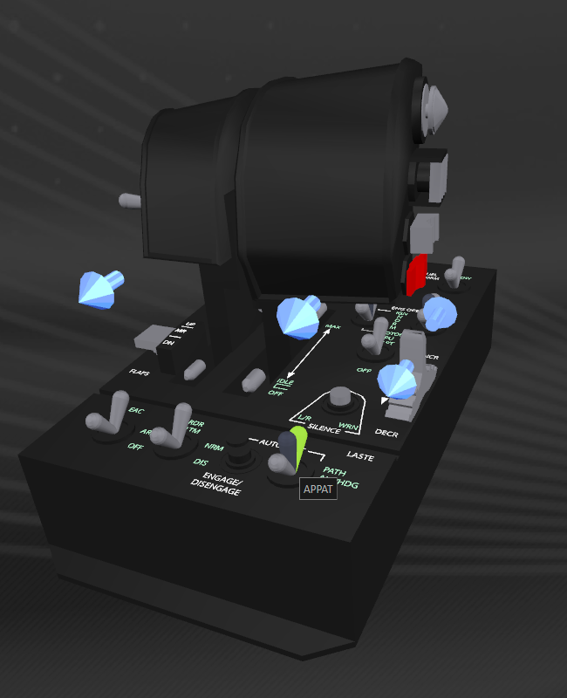  
Throttle APPAT (Autopilot Path)

MILD applies a small amount of curve to the joystick and rudder.  
The joystick and rudder have a slight non-linear rate of response.

The S-Curve causes the response to be slightly slower at the beginning of travel away from centre and gets faster the further from centre you move the stick (or rudder).

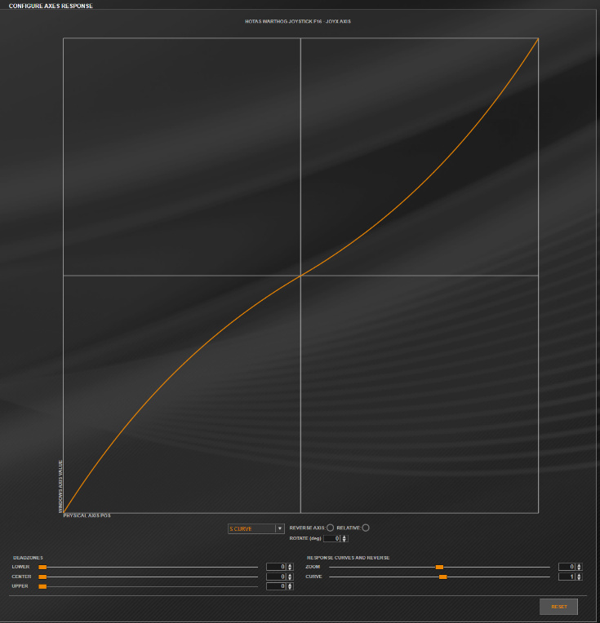  
 Joystick Curves set to 1 (Non-Linear Response)

(…curves continued)

Switch Usage Action

APAH APAH Set Joystick and Rudder curves to OFF (0)

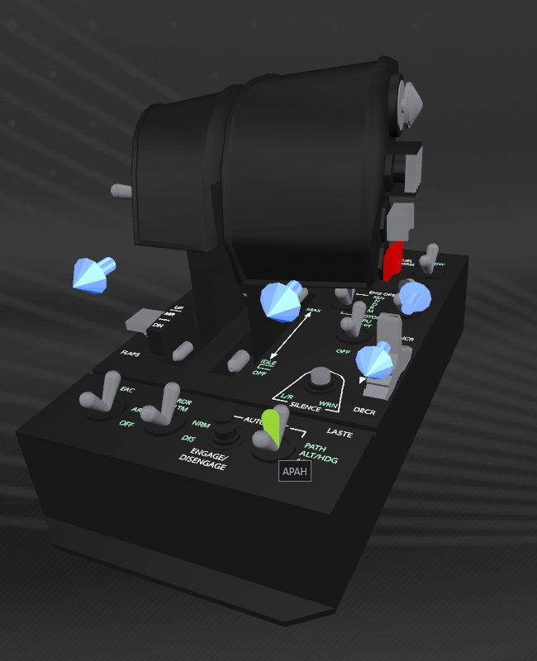  
Throttle APAH (Autopilot ALT/HDG)

Default position for this switch. No curves means that the joystick and rudder axes have a linear response. That is, it increases the roll or pitch rate in a consistent manner as you move the stick all the way left, right, up, or down.

As the script applies the same curve profiles to the joystick and rudder when switching, the same theory applies to the rudder.

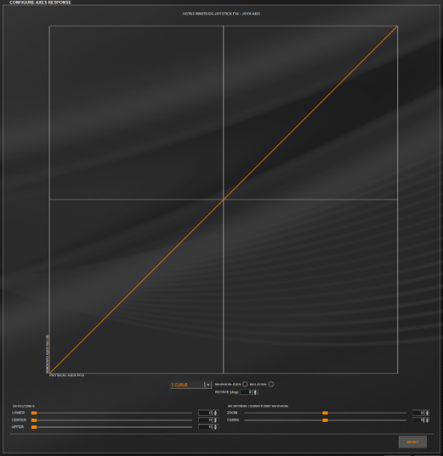  
 Joystick Curves set to 0 (linear response)

(…curves continued)

Switch Usage Action

APALT-O APALT Set Joystick and Rudder curves to SLOW (3)  
APALT-I S3+APALT Set Joystick and Rudder curves to SLOWEST (4)

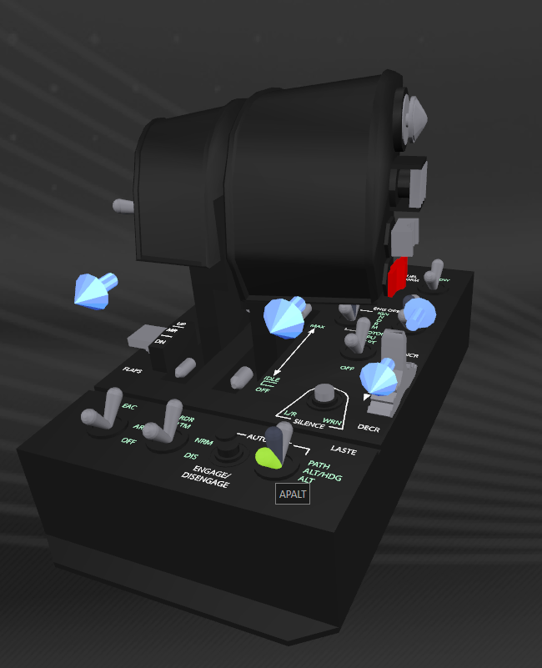  
Throttle APALT (Autopilot ALT)

At a curve profile of ‘SLOW’ (3) or ‘SLOWEST’ (4), the Joystick/Rudder response starts quite a bit slower and then gets a fair bit faster the more you move the throttle or rudder from the centre position. This is most useful when learning and using Flight Assist Off (FA-OFF).

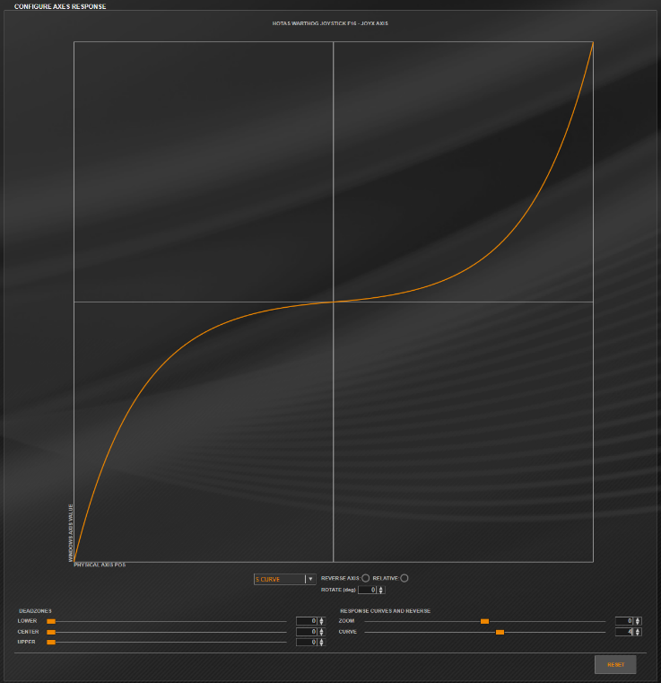  
 Joystick Curves set to 4 (non-linear response)

(…curves continued)

Switch Usage Action

S4 S4 1st press - Toggles FA-OFF and sets joystick & rudder curves to the value you choose in the UserSettings file (eg MEDIUM or SLOW)  
 2nd press - Toggles FA-ON and resets curve profile to the associated  
 autopilot switch setting

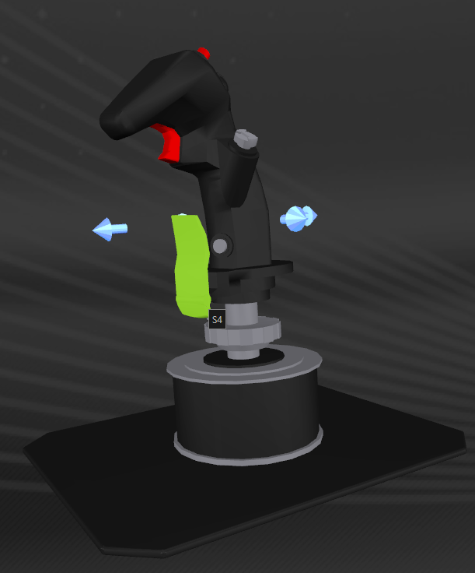  
Joystick S4 (Pinky lever)

FA-OFF: Status LED 1

The curves that FA-OFF will use can be set via the ‘FAOFFCurves’ variable within the ED_UserSettings.tmh file. Valid settings are ‘OFF’, ‘MILD’, ‘MEDIUM’ or ‘SLOW’

Console printout each time curves change can be enabled via ‘CurveInfo’ variable within ED_UserSettings.tmh file. Valid settings are ‘PRINT’ or ‘NOPRINT’

Note: The above settings are case sensitive.

(…curves continued)

Axis Usage Action

THR_FC THR_FC Used to adjust radar range

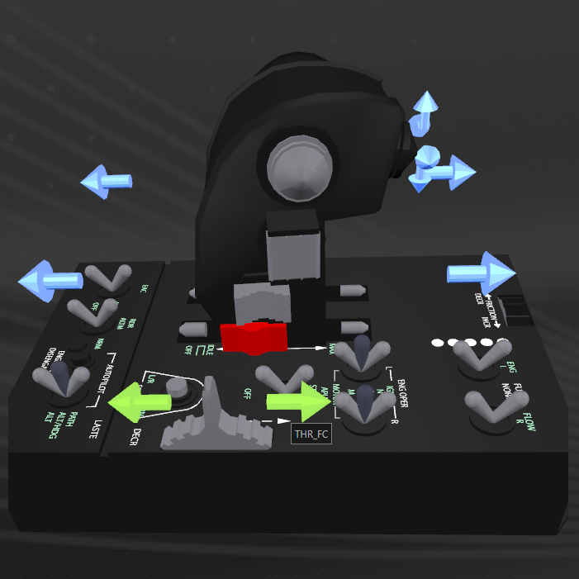  
Throttle THR_FC (Slider)

The slider axis requires ‘SetCustomCurve’ which is selected automatically depending on flight mode.   
Flight mode is detected in the script each time your flight mode changes from normal, super cruise, FSS Scanner or DSS Scanning (surface probes, front/rear planet view).

Mode 0: linear. Used for FSS Mode Radar  
 Curve Profile 0 = (0,0, 25,25, 50,50, 75,75, 100,100)

Mode 1: non-linear. Used for normal flight and SRV  
 Curve Profile 1 = (0,0, 40,25, 75,50, 85,75, 100,100)  
 i.e. When slider is at 40%, Windows DX value is at 25% etc.

Mode 2: non-linear. Used for Super cruise  
Curve profile 2 = (0,0, 50,10, 75,30, 90,50, 100,100)

Note: J-Curve settings (via ‘SetJCurve’ statement in script) do not work as well as ‘SetCustomCurve’

Most of the settings for each of the curve functions can be found within the ED_UserSettings.tmh file under the ‘Axis Curves’ section, or in the ED_Functions file (look for fnSetJoystickCurves() and fnSetSliderCurve() functions.

Refer ‘Axes’ chapter starting on p27 in the [Target Script Editor Basics Manual v1.5](https://ts.thrustmaster.com/download/accessories/pc/hotas/software/TARGET/TARGET_Script_Editor_Basics_v1.5_ENG.pdf) for more details on ‘S’, ‘J’ and ‘Custom’ curves.

(…curves continued)

Axis Usage Action

SCX SCX Slew Control X-Axis. Used for Lateral Thrusters  
SCY SCY Slew Control Y-Axis. Used for Vertical Thrusters  
  
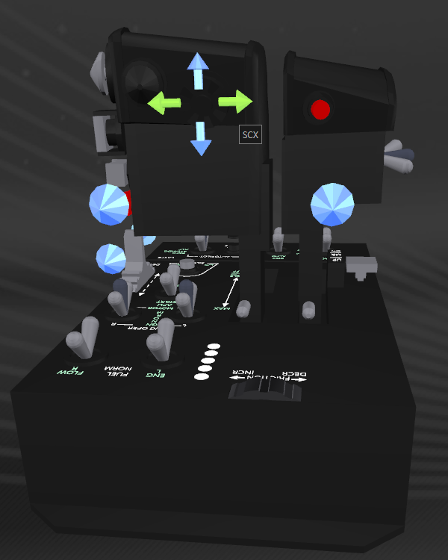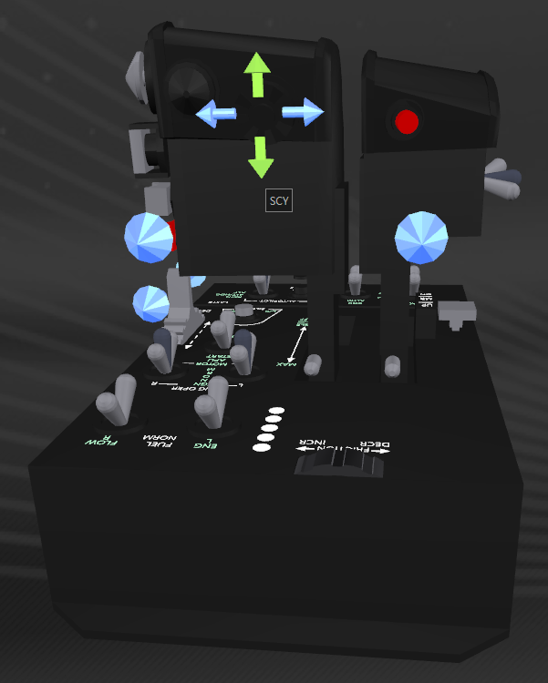

Throttle SCX (Slew Control) Throttle SCY (Slew Control)

Curves for the Slew Control are also set when we change the Joystick curves.  
The three profiles are all set the same (linear) but can be changed via curve arrays within ED_UserSettings.tmh to suit your own tastes.

I use a slight centre dead zone, as this control is quite sensitive.

NOTE: I have modified my WARTHOG HOTAS by replacing the slew control ‘nub’ with an analogue control replacement that I obtained from:

<https://deltasimelectronics.com/products/thumbstick-slew-sensor-adapter>

This is a fantastic upgrade to the HOTAS, which I heartily recommend.  
It turns what I consider a relatively useless control that I did not/would not use, into something supremely useable which I cannot do without!

# Joystick Controller

Switch Usage Action

TG1-U PSF+TG1 Increment Primary Trigger Action - Discovery Scanner Mode - Mining Laser Mode - Pulse Wave Scanner Mode  
  
TG1-M TG1 Primary trigger default action (press to fire, release to stop)  
  
TG1-D PSB+TG1 Disco scan. Press+Release to fire. Trigger released after 6.1 secs  
 Mining laser. Press to fire, press to stop Pulse Wave Scanner. Press+Release to start. Pulse sent every 7 seconds. Press+Release to stop

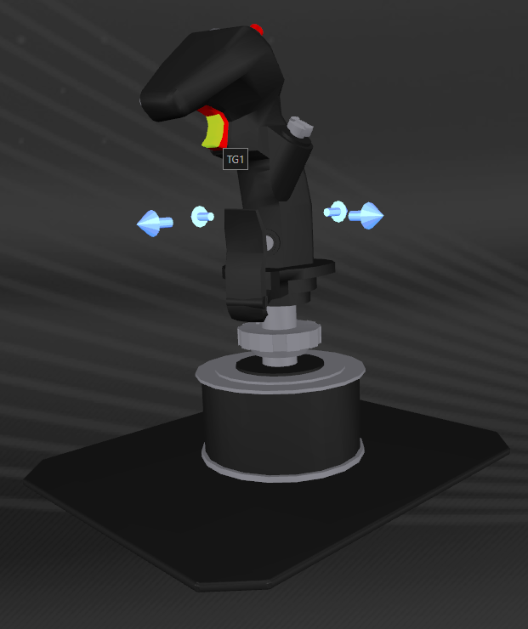  
Joystick TG1 (Primary Fire)

(… JOYSTICK continued)

Switch Usage Action

TG2 TG2 (not mapped)

Switch Usage Action

S1-U PSF+S1 Toggle HUD between Analysis and Combat Modes

S1-M S1 Toggle Hard points (normal flight mode)  
 Toggle HUD Mode (in Super Cruise flight mode)

S1-D PSB+S1 Toggle Joystick X-Axis between ROLL and YAW

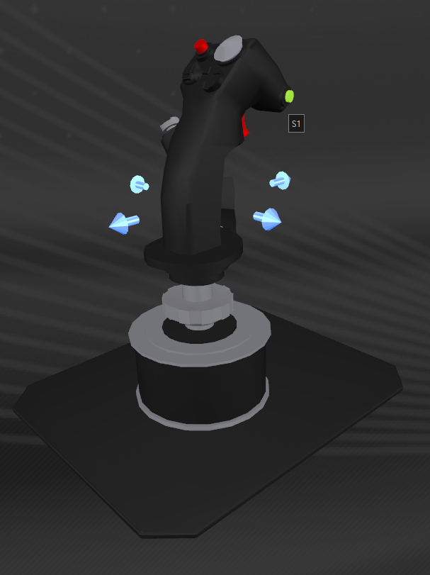  
Joystick S1 (Master Mode Control)  
  
NOTE: When in Super cruise, S1-M toggles HUD mode automatically

(… JOYSTICK continued)

Switch Usage Action

S2-U PSF+S2 Increment Secondary Trigger Action - Discovery Scanner Mode - Mining Laser Mode - Pulse Wave Scanner Mode  
  
S2-M S2 Secondary trigger default action (press to fire, release to stop)  
  
S2-D PSB+S2 Disco scan. Press+Release to fire. Trigger released after 6.1 secs  
 Mining laser. Press to fire, press to stop Pulse Wave Scanner. Press+Release to start. Pulse sent every 7 seconds. Press+Release to stop

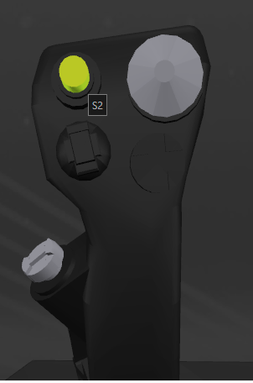  
Joystick S2 (Secondary Fire/Weapons Release)

(… JOYSTICK continued)

Switch Usage Action

H1U-U PSF+H1U Toggle FSS Mode

H1U-M H1U Select Next Fire Group

H1U-D PSB+H1U Turn off DSS Mode

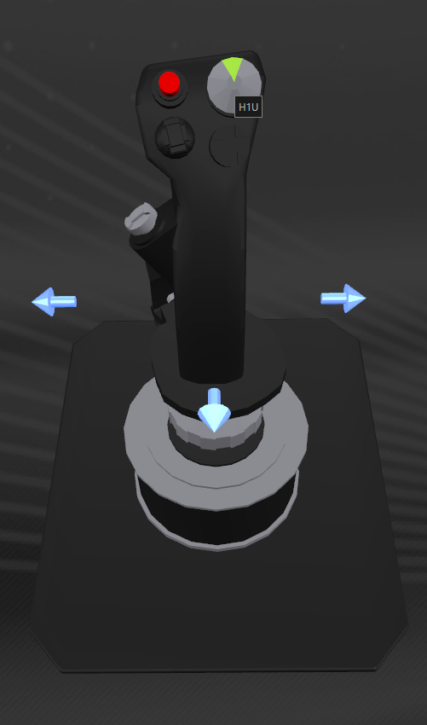  
Joystick H1U (China Hat – Up)

(… JOYSTICK continued)

Switch Usage Action

H1D H1D Select Previous Fire Group

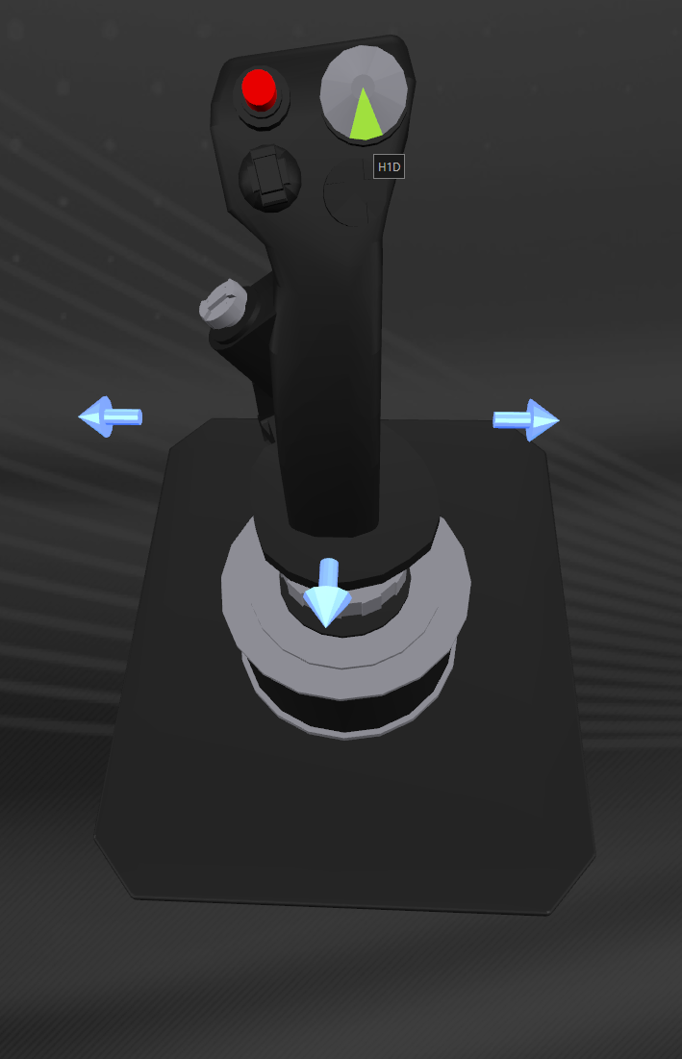  
Joystick H1D (China Hat – Down)

(… JOYSTICK continued)

Switch Usage Action

H1L H1L Tempo. Press and hold for 0.5 seconds toggles landing gear  
 Short press does nothing.

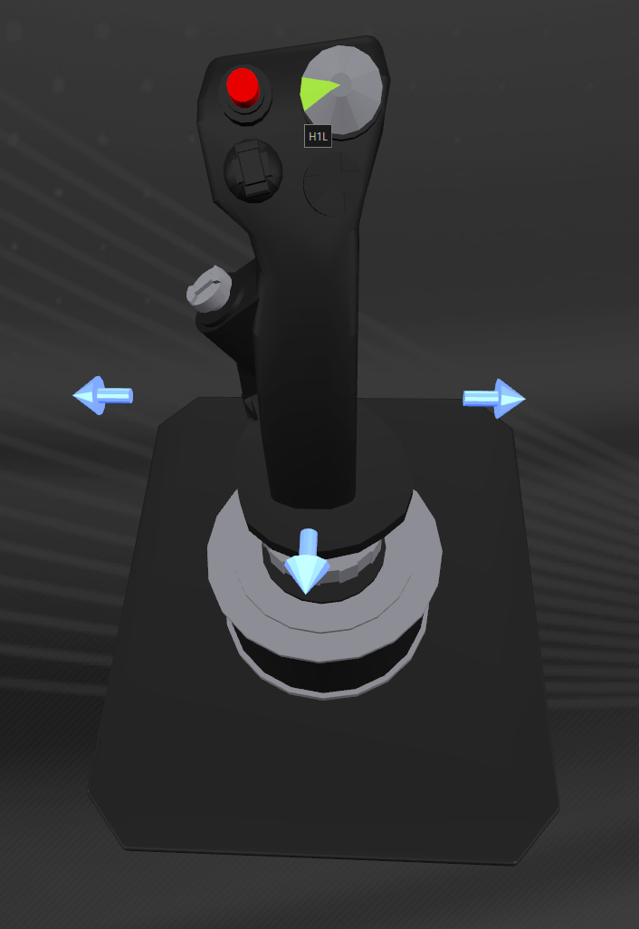  
Joystick H1L (China Hat – Left)

Landing Gear: Status LED 5

Press and hold H1L for 0.5 Seconds to toggle the landing gear.  
This prevents accidental deployment during combat if you accidentally hit H1L instead of H1U (Next Fire group) or H1D (Previous Fire group)

The 0.5-second delay can be changed via the ‘LongPress’ variable defined in the UserSettings file.

(… JOYSTICK continued)

Switch Usage Action

H1R-U PSF+H1R Toggle Night Vision ON/OFF

H1R-M H1R Tempo. Press and hold for 0.5 seconds toggles lights  
 Short press does nothing. Prevents accidental toggle of lights

H1R-D PSB+H1R (not mapped)

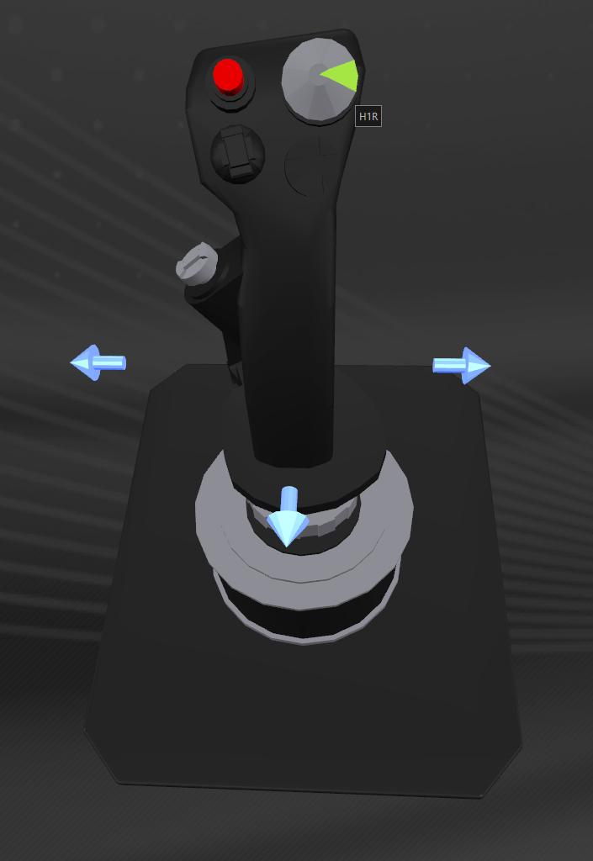  
Joystick H1R (China Hat – Right)

Toggle Lights: Status LED 2

Ship Lights simply toggle ON/OFF

SRV lights cycle ON/HI BEAM/OFF

The 0.5-second delay can be changed via the ‘LongPress’ variable defined in the UserSettings file.

(… JOYSTICK continued)

Switch Usage Action

H2U-U PSF+H2U Toggle Planet View, Front/Back (Must be in FSS Mode)

H2U-M H2U Select Target Ahead

H2U-D PSB+H2U Select Target Ahead

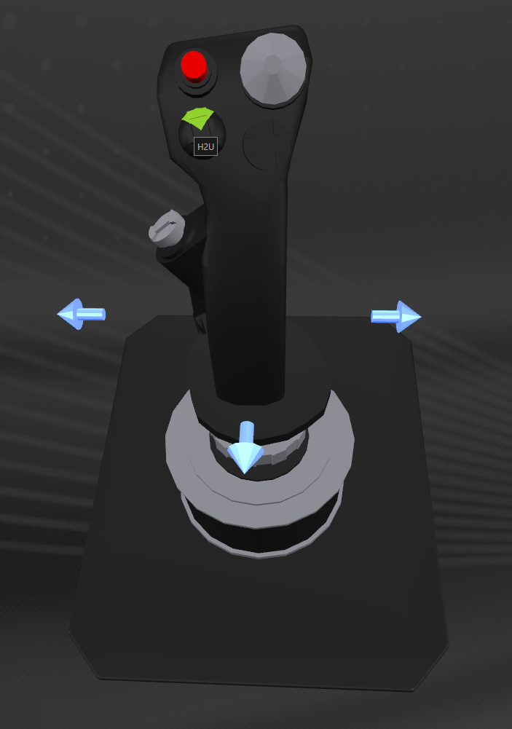  
Joystick H2U (Target Designator – Up)

(… JOYSTICK continued)

Switch Usage Action

H2D-U PSF+H2D (not mapped)

H2D-M H2D Select Highest Threat

H2D-D PSB+H2D Select Wing Man’s Target

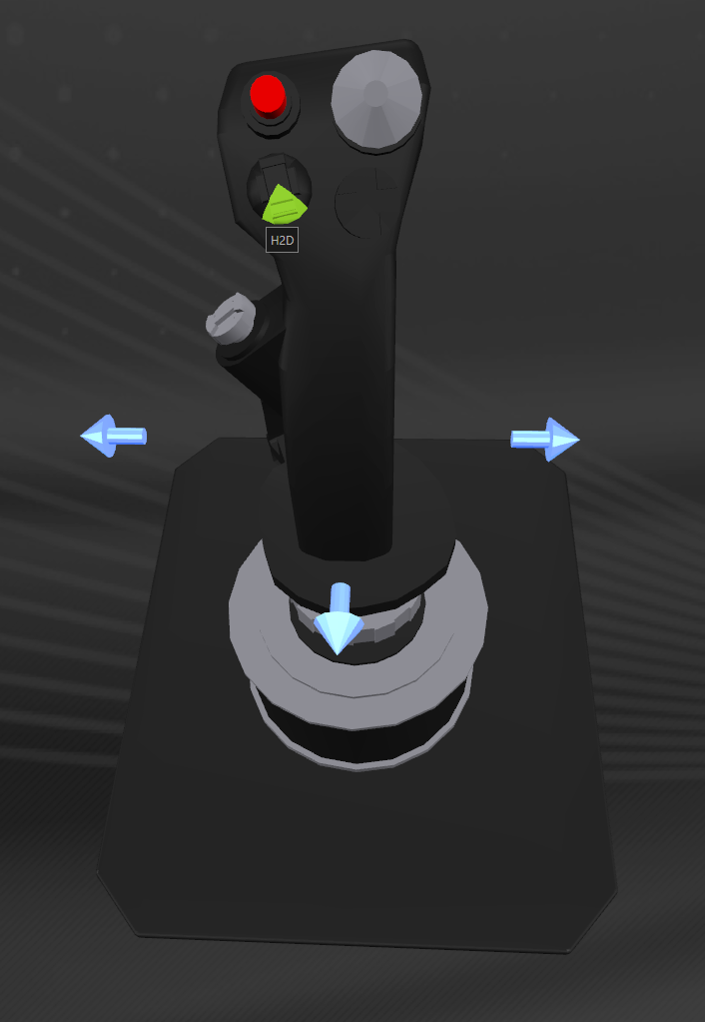  
Joystick H2D (Target Designator – Down)

(… JOYSTICK continued)

Switch Usage Action

H2L-U PSF+H2L (not mapped)

H2L-M H2L Select next ship

H2L-D PSB+H2L Select next wingman (sequences each wingman in turn)

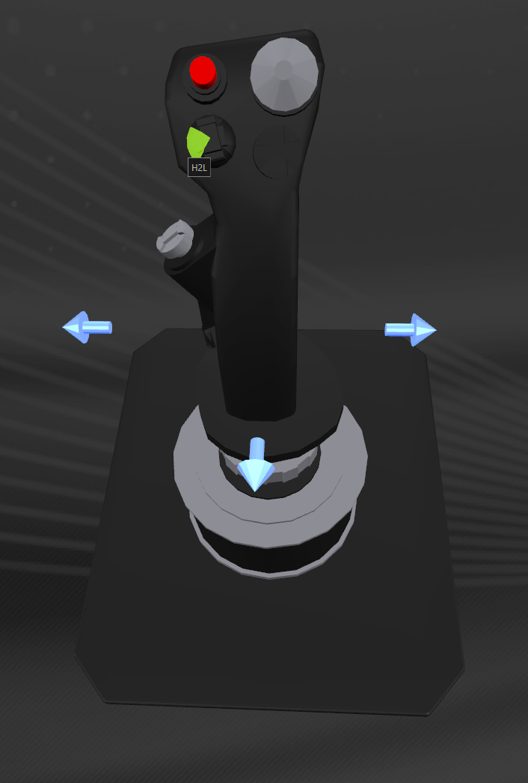  
Joystick H2L (Target Designator – Left)

(… JOYSTICK continued)

Switch Usage Action

H2R-U PSF+H2R (not mapped)

H2R-M H2R Select next hostile ship

H2R-D PSB+H2R Select Wingman’s NAV Lock

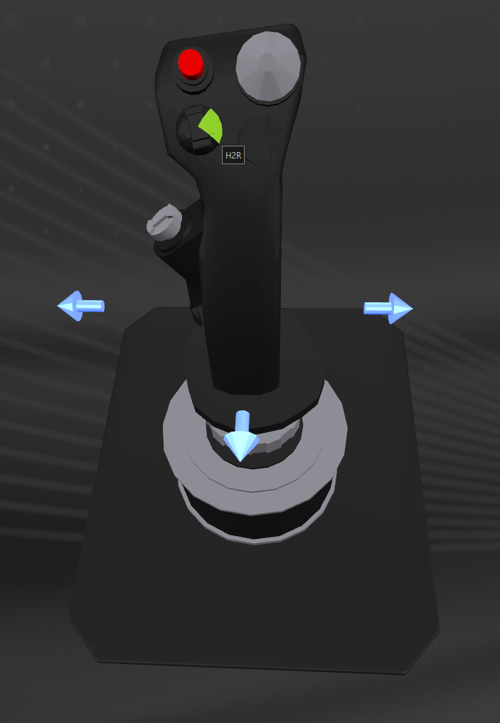  
Joystick H2R (Target Designator – Right)

(… JOYSTICK continued)

Switch Usage Action

H3U H3U PIP Management – PIPs to Engines

H3D H3D Balance PIPs

H3L H3L PIPs to Systems (Shields)

H3R H3R PIPs to Weapons

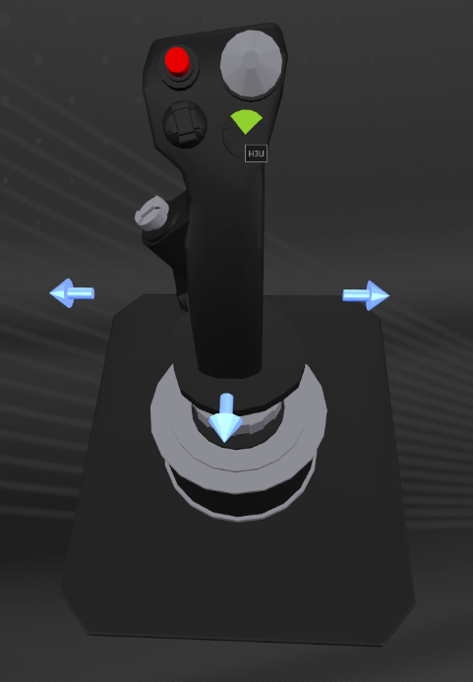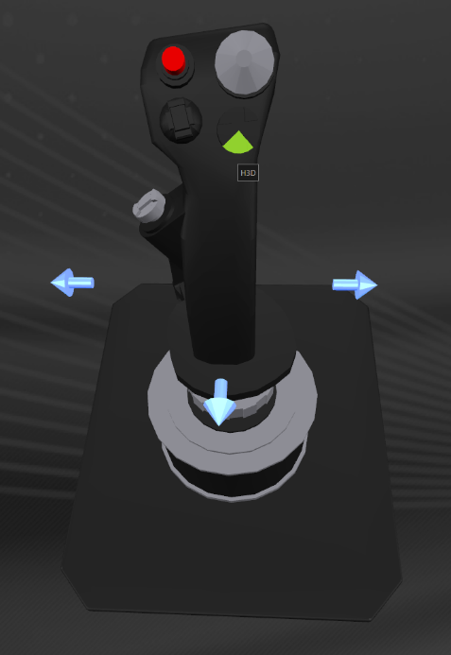

Joystick H3D (Data Mgmt – Up) Joystick H3U (Data Mgmt – Down)

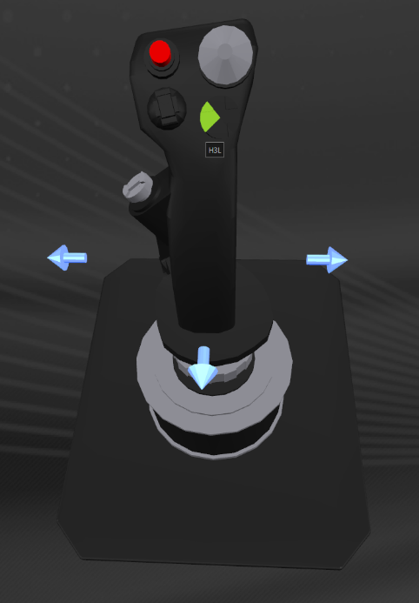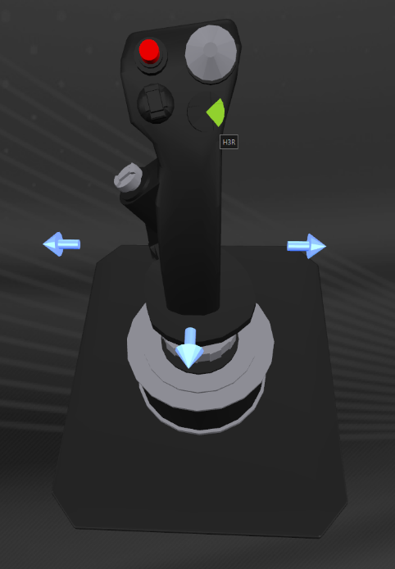

Joystick H3L (Data Mgmt – Left) Joystick H3R (Data Mgmt – Right)

The script has six PIP Modes selectable via H4P (see below)

(… JOYSTICK continued)

Switch Usage Action

H4P-U PSF+H4P Reset PIP Mode to DefaultPIPMode (set in ED_UserSettings.tmh)

H4P-M H4P Select Next PIP Mode. (0 - 5)  
 (5 wraps to 0)

H4P-D PSB+H4P Select Previous PIP Mode (5 - 0)  
 (0 wraps to 5)

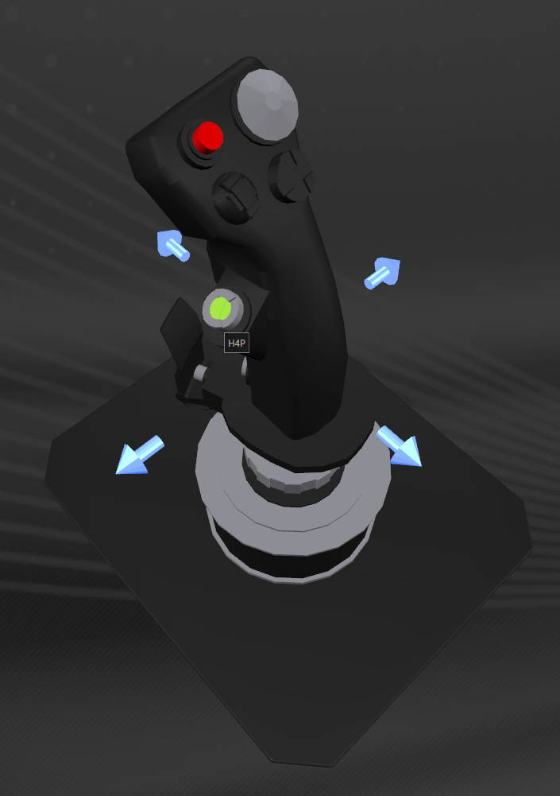  
Joystick H4P (Countermeasures – Press)

|  |  |  |
| --- | --- | --- |
| PIP Mode 0: | Single PIPs | 1 press = 1 PIP |
| PIP Mode 1: | Double PIPs | 1 press = 2 PIPs |
| PIP Mode 2: | Attack | SYS = [4 0 2], ENG = [0 4 2], WEP = [0 2 4] |
| PIP Mode 3: | Defend | SYS = [4 2 0], ENG = [2 4 0], WEP = [2 0 4] |
| PIP Mode 4: | Recharge | SYS = [4 1 1], ENG = [1 4 1], WEP = [1 1 4] |
| PIP Mode 5: | 3+3 | SYS = [3 3 0], ENG = [0 3 3], WEP = [3 0 3] |

(… JOYSTICK continued)

Switch Usage Action

H4U-U PSF+H4U ‘Double Bank’ Fire 2x Shield Cell Banks (SCB) + 1x Heatsink

H4U-M H4U Tempo. Short Press = Fire 1x SCB, Long Press = 1x SCB + 1x Heatsink

H4U-D PSB+H4U FSS or Camera Zoom - IN

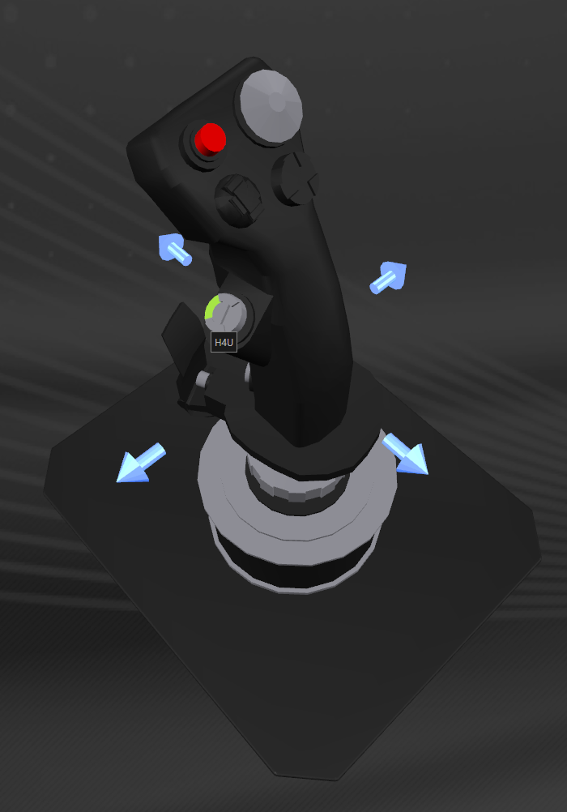  
Joystick H4U (Countermeasures – UP)

(… JOYSTICK continued)

Switch Usage Action

H4D-U PSF+H4D (not mapped)

H4D-M H4D Fire 1x Heatsink

H4D-D PSB+H4D FSS or Camera Zoom – OUT

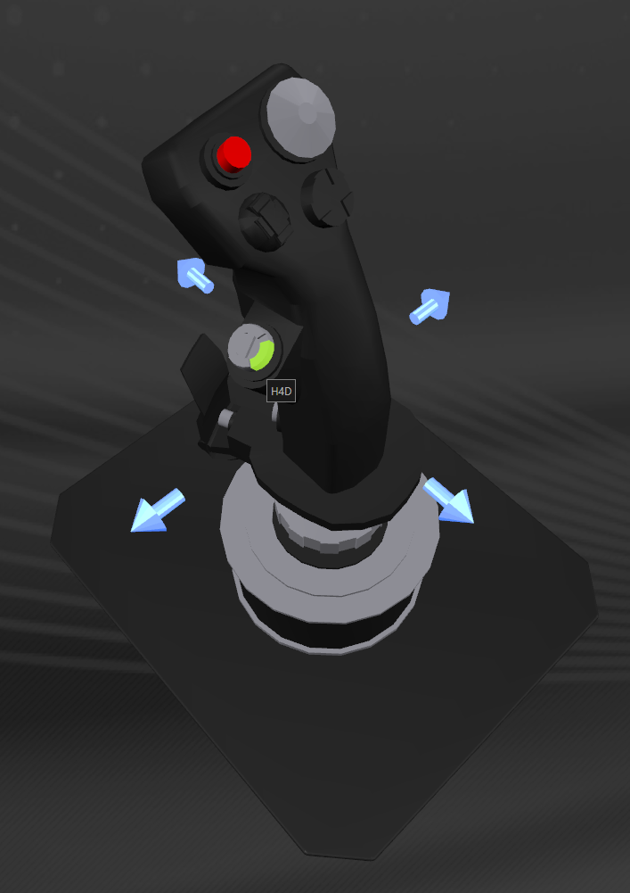  
Joystick H4D (Countermeasures – DOWN)

(… JOYSTICK continued)

Switch Usage Action

H4L-U PSF+H4L (not mapped)

H4L-M H4L Electronic Countermeasures (ECM). Hold to charge, Release to Fire

H4L-D PSB+H4L Camera Blur – OUT

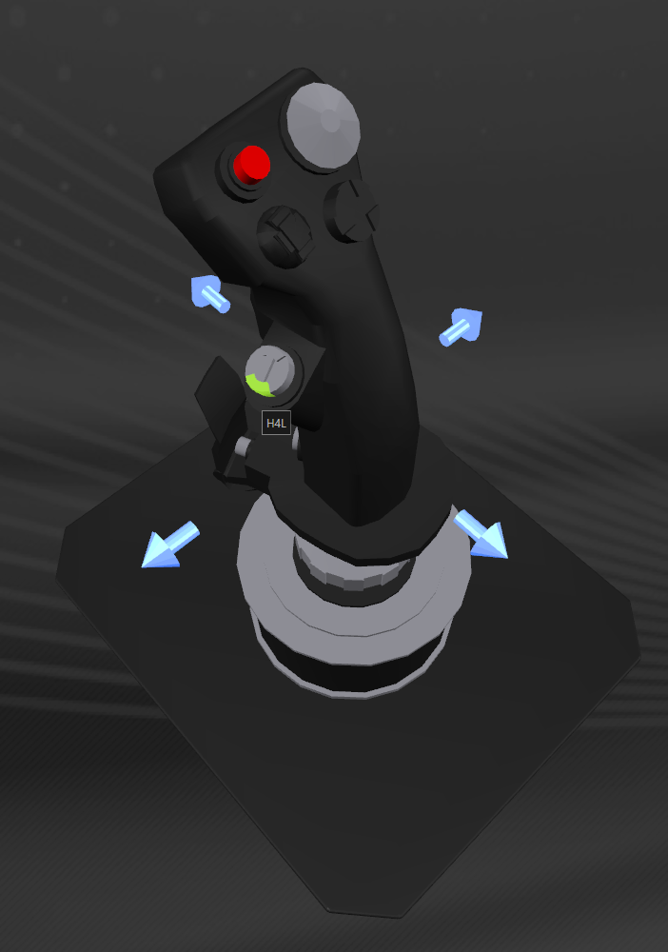  
Joystick H4L (Countermeasures – LEFT)

(… JOYSTICK continued)

Switch Usage Action

H4R-U PSF+H4R (not mapped)

H4R-M H4R Fire 1x Chaff

H4R-D PSB+H4R Camera Blur – IN

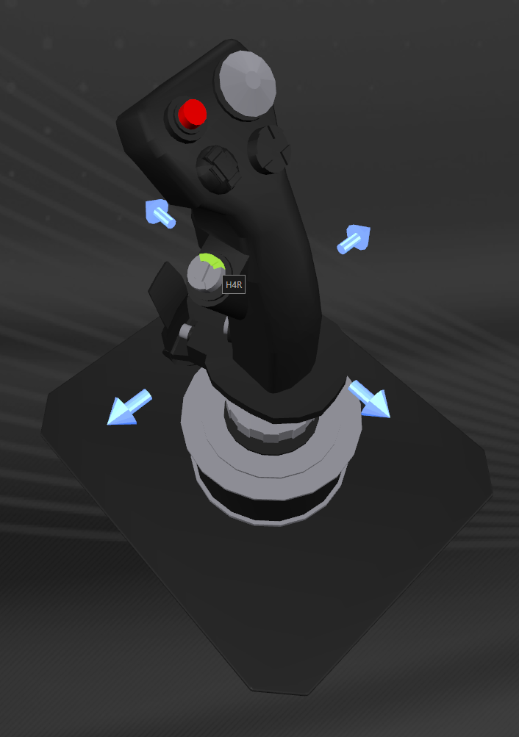  
Joystick H4R (Countermeasures – RIGHT)

# Throttle Control Lever

Switch Usage Action

SC-U PSF+SC Toggle Connection status. Shows Bandwidth counter

SC-M SC Centres EDTracker

SC-D PSB+SC (not mapped)

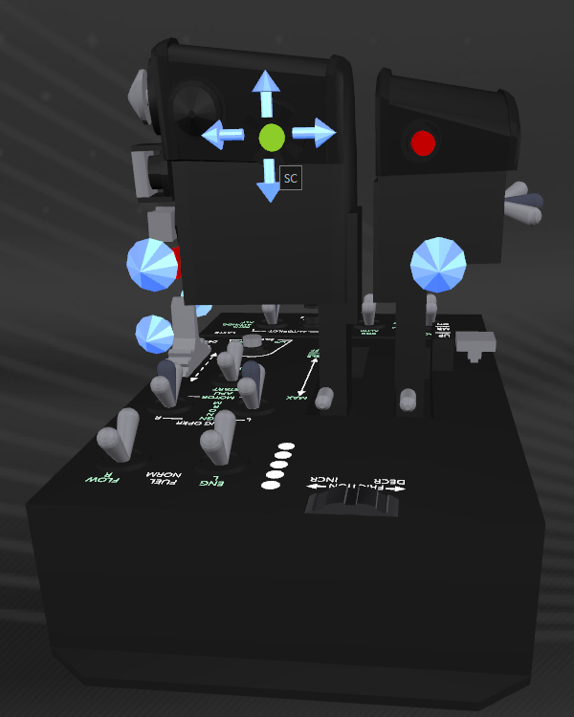  
Throttle SC (Slew Control Press Button)

The Slew Control finger controlled mini joystick is also used for lateral thrust

(… Throttle LEVER continued)

Switch Usage Action

LTB-U PSF+LTB Toggles external ‘free camera view’ and turn off GUI

LTB-M LTB Toggle Head look ON/OFF

LTB-D PSB+LTB (not mapped)

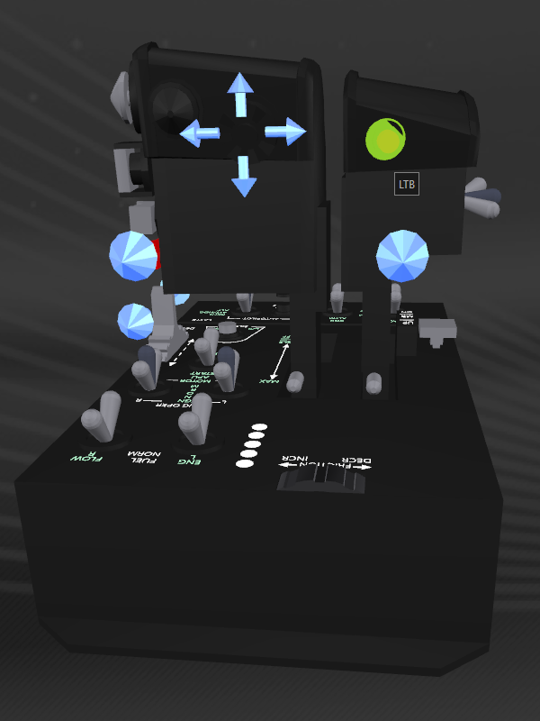  
Throttle LTB (Left Throttle Button)

(… Throttle LEVER continued)

Switch Usage Action

CSU-I S3+CSU Alternate Pitch Up  
CSU-O CSU Engage/Cancel/Disengage Super cruise  
  
CSD-I S3+CSD Alternate Pitch Down  
CSD-O CSD Engage/Cancel System Jump (Hyperspace)

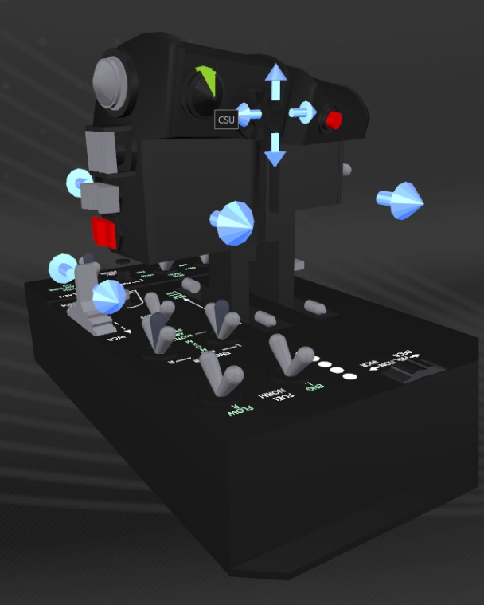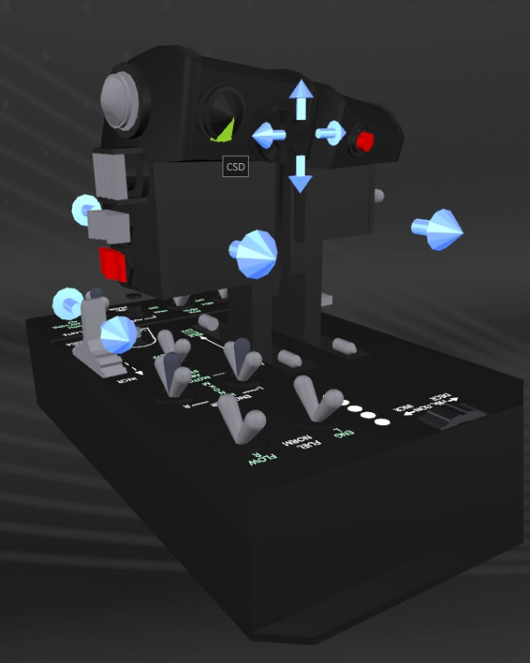  
 Throttle CSU (Coolie Switch – UP) Throttle CSD (Coolie Switch – DOWN)

The script can detect a wide range of game states via status.json including if we are in Super cruise versus Hyper jump, when we are Mass Locked, when the FSD is cooling down or charging up.

The script also detects when we drop out of Super cruise and if this was initiated or we have dropped out via interdiction, hyperdicted, or drop from orbital cruise etc.

When we Charge the FSD, the script will automatically retract the hard points, landing gear and cargo scoop if needed.

When interdicted, as soon as we drop from Super cruise, the script will automatically select Combat HUD mode, deploy hard points and endeavour to select the highest threat.

(… Throttle LEVER continued)

Switch Usage Action

CSL-I S3+CSL Alternate Yaw Left  
CSL-O CSL Select Next System in route  
  
CSR-I S3+CSR Alternate Yaw Right  
CSR-O CSR Toggle Orbit Lines ON/OFF

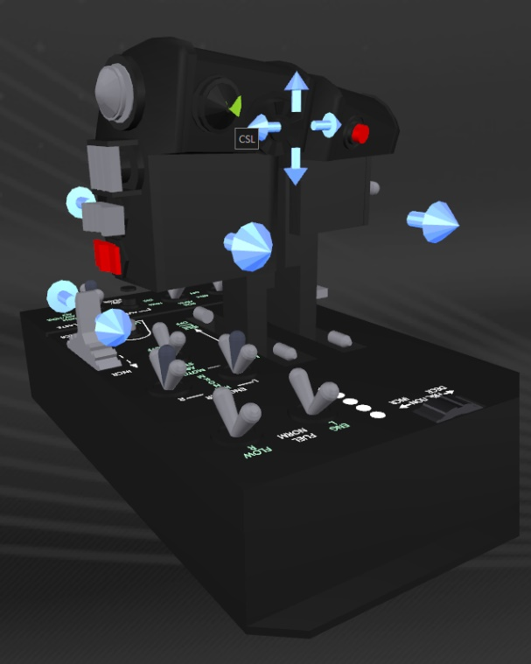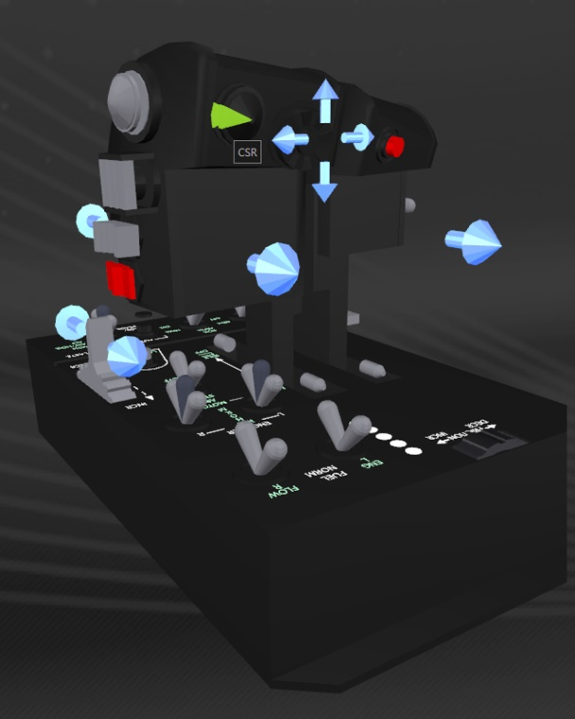  
Throttle CSL (Coolie Switch – LEFT) Throttle CSR (Coolie Switch – RIGHT)

If you do not have a set of rudder pedals, you can yaw the ship using CSL and CSR respectively using the S3 (Joystick pinky button, not lever) IO shift function

(… Throttle LEVER continued)

Switch Usage Action

MSU MSU Select NEXT Comms Channel

MSD MSD Select PREVIOUS Comms Channel

MSL MSL Output Communications Status

MSR MSR Output Communications Status

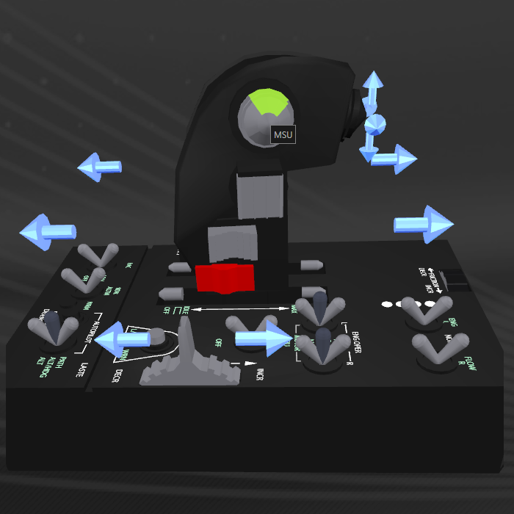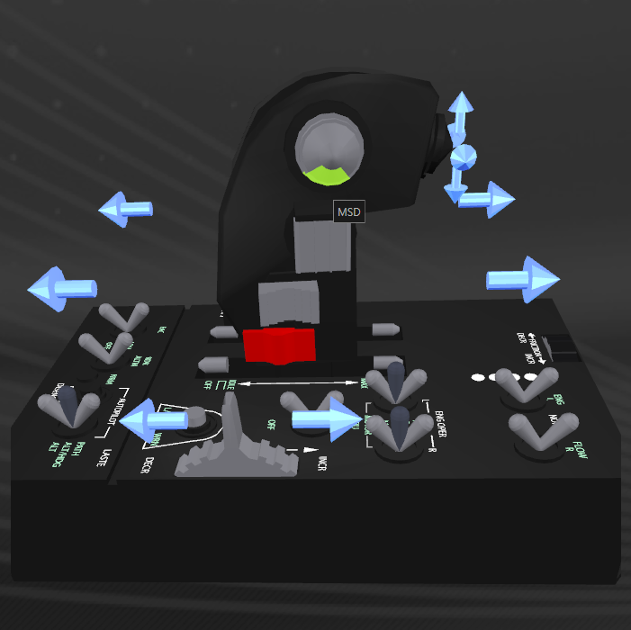

Throttle MSU (Mike Switch – UP) Throttle MSD (Mike Switch – DOWN)

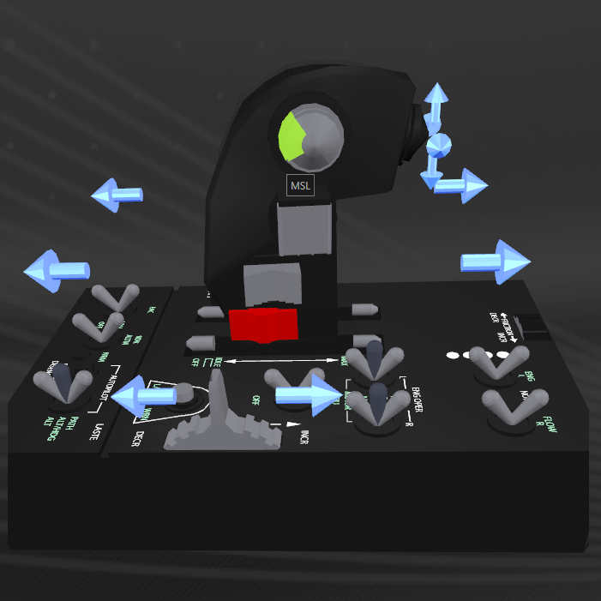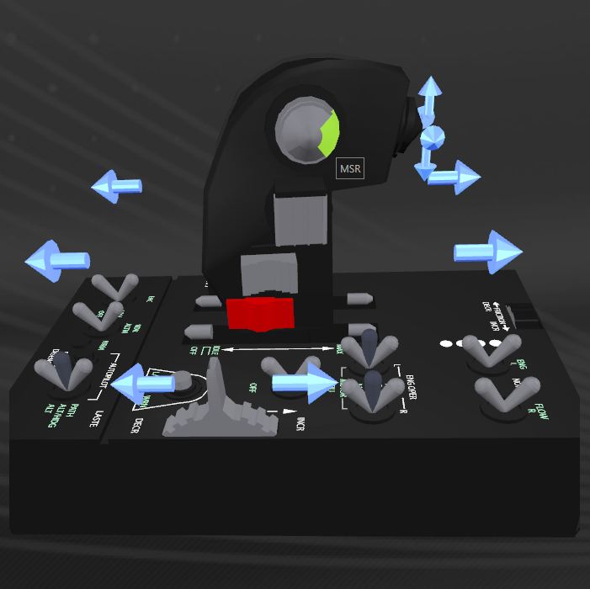

Throttle MSL (Mike Switch – LEFT) Throttle MSR (Mike Switch – Right)

(… Throttle LEVER continued)

Switch Usage Action

MSP-I S3+MSP Toggle Push-To-Talk Mode (PTT v Push ON/Push OFF)

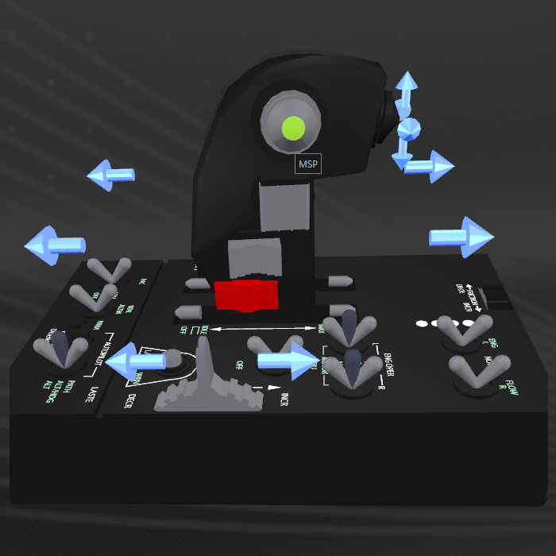  
Throttle MSP (Mike Switch – PRESS)

The ‘Mike Switch’ is used for voice communications functions.

(… Throttle LEVER continued)

Switch Usage Action

SPDF-U PSF+SPDF Reverse Thrust (no speed brake)

SPDF-M SPDF Reverse Thrust (+Speed brake if hard points are deployed)

SPDF-D PSB+SPDF Re-align switch to action if out of synch

The landing gear used as an auto speed brake by hitting ‘Reverse’ when in normal flight.  
This will automatically deploy the landing gear, then retract 5 seconds later.  
[Boost-bleeding](https://www.youtube.com/watch?v=hqQPyEhAosI) can be accomplished by hitting boost, then Reverse.

Reverse thrust turned off when switch returned to middle position.

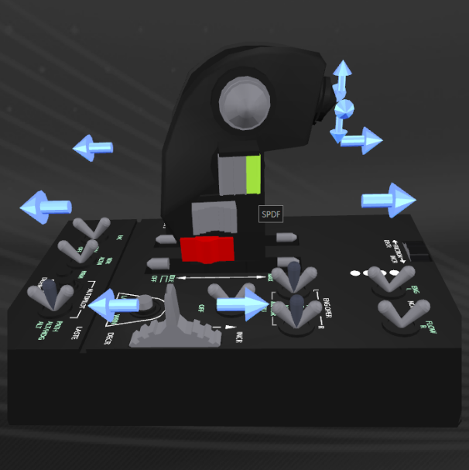

Throttle SPDF (Speed Brake – FORWARD)

Switch Usage Action

SPDB SPDB Boost (momentary action switch)

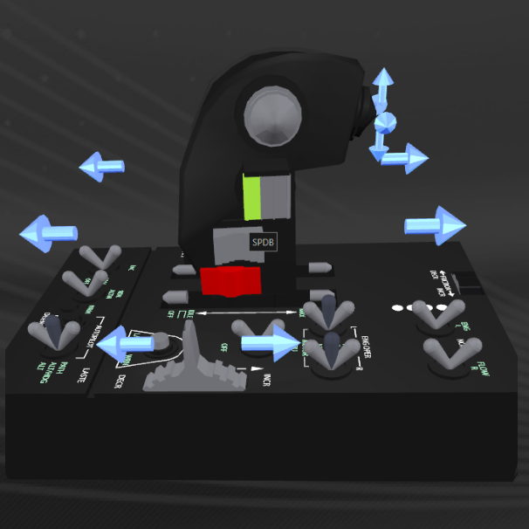

Throttle SPDB (Speed Brake – BACK)

(… Throttle LEVER continued)

Switch Usage Action

BSF-U PSF+BSF Macro: Toggles Wingman Beacon WING/OFF  
 (Right Panel must be at home position or this won’t work)

BSF-M BSF (not mapped)

BSF-D PSB+BSF Toggle Text-To-Speech feedback ENABLED/DISABLED

Switch Usage Action

BSB-U PSF+BSB Toggle ‘Report Crimes against me’ ON/OFF  
 (Right panel must be at home position or this won’t work)

BSB-M BSB (not mapped)

BSB-D PSB+BSB (not mapped)

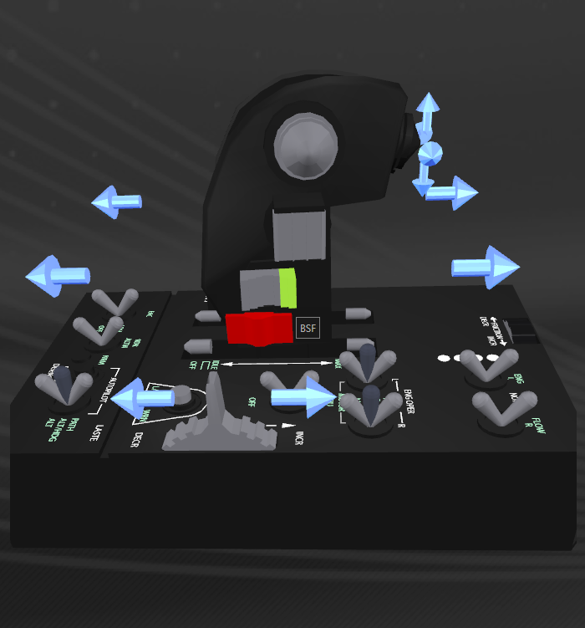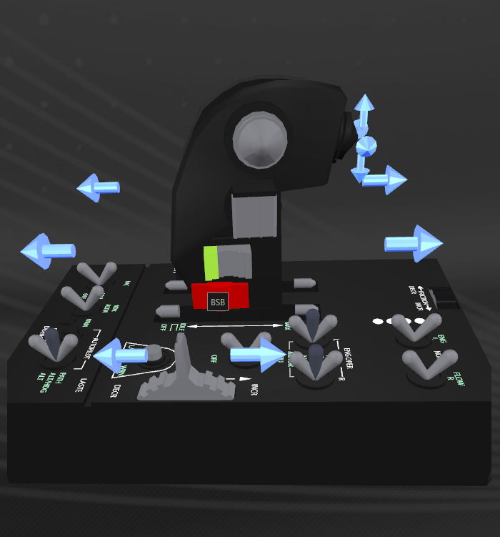  
Throttle BSF (Boat Switch – FORWARD) Throttle BSB (Boat Switch – BACK)

NOTE:   
The Wingman Beacon and Report Crimes macros require the SYSTEM Panel (Right Panel) to be at home position or undesired/random results will happen. Home position is the left most TAB in the Top Left position.

If you are used to manually accessing the panels frequently, consider not using these functions, or, get in the habit of returning to the home position manually each time.

This also applies to the ‘Docking Request’ macro and NAV (Target) Panel (Left Panel)

(… Throttle LEVER continued)

Switch Usage Action

CHF CHF Select next subsystem on targeted ship (momentary action switch)

CHB CHB Select previous subsystem on targeted ship (momentary action)

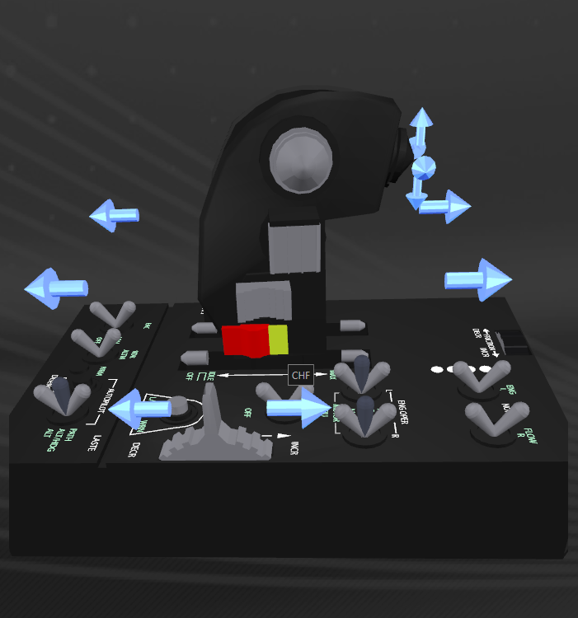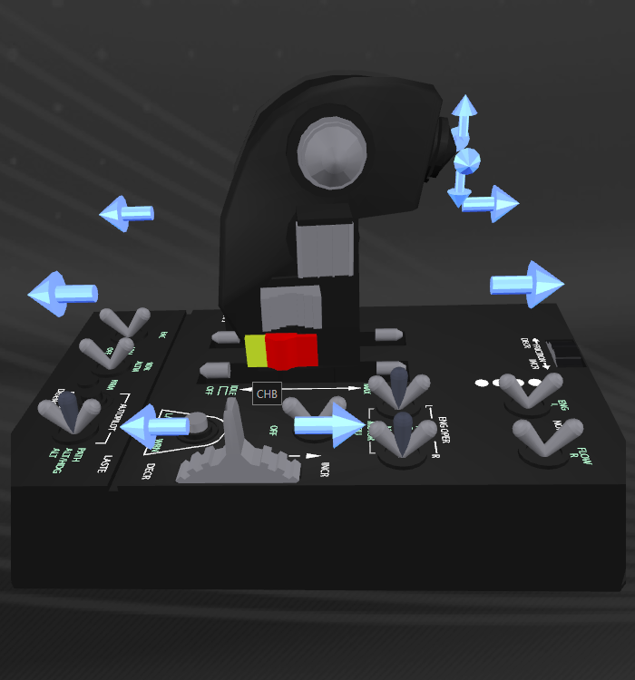  
Throttle CHF (China Hat – FORWARD) Throttle CHB (China Hat – BACK)

# Throttle Control Base

Switch Usage Action

APPAT-O APPAT Set Joystick/Rudder curves to MILD

APPAT-I S3+APPAT Set Joystick/Rudder curves to MEDIUM

APAH APAH Set Joystick/Rudder curves to OFF

APALT-O APALT Set Joystick/Rudder curves to SLOW

APALT-I S3+APALT Set Joystick/Rudder curves to SLOWEST

Refer to Axis Curves and Curve Control



Throttle APPAT (Auto Pilot - Path) Throttle APALT (Auto Pilot - ALT)

(… Throttle BASE continued)

Switch Usage Action

EACON-I S3+EACON Toggle Silent Running – STROBE

EACON-O EACON Toggle Silent Running – ON

EACOFF EACOFF Toggle Silent Running – OFF

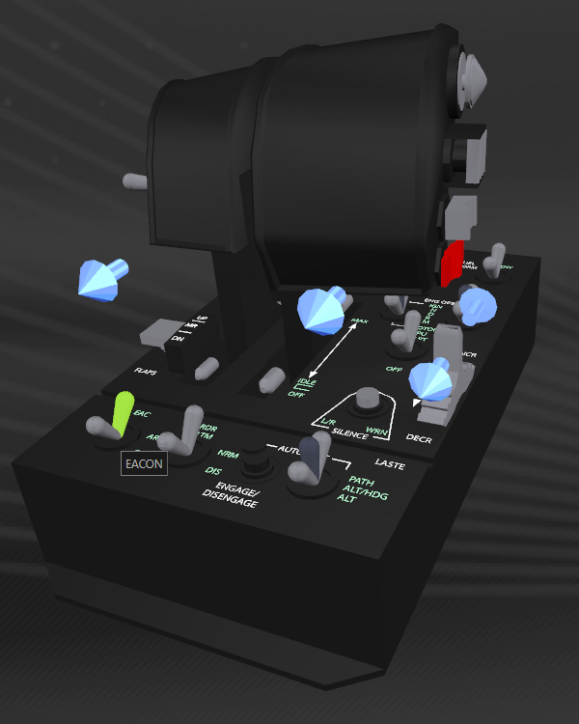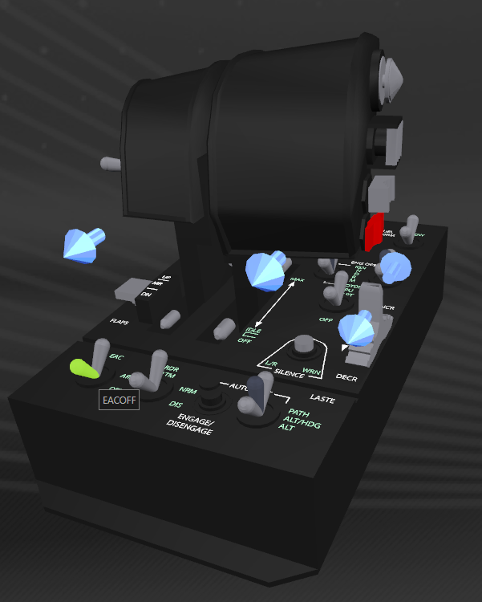

Throttle EACON (Enh Attitude Control – ON) Throttle EACOFF (Enh Attitude Control – OFF)

Silent Running: Status LED 3

STROBE mode toggles Silent Running on/off every 2 seconds. This breaks target lock of attacking ships.

(… Throttle BASE continued)

Switch Usage Action

RDRNRM-IU S3+PSF+RDRNRM Jettison Cargo

RDRNRM-OU PSF+RDRNRM (not mapped)

RDRNRM-IM S3+RDRNRM (not mapped)

RDRNRM-OM RDRNRM Deploy Cargo Scoop

RDRNRM-ID S3+PSB+RDRNRM (not mapped)

RDRNRM-OD PSB+RDRNRM (not mapped)

RDRDIS RDRDIS Retract Cargo Scoop

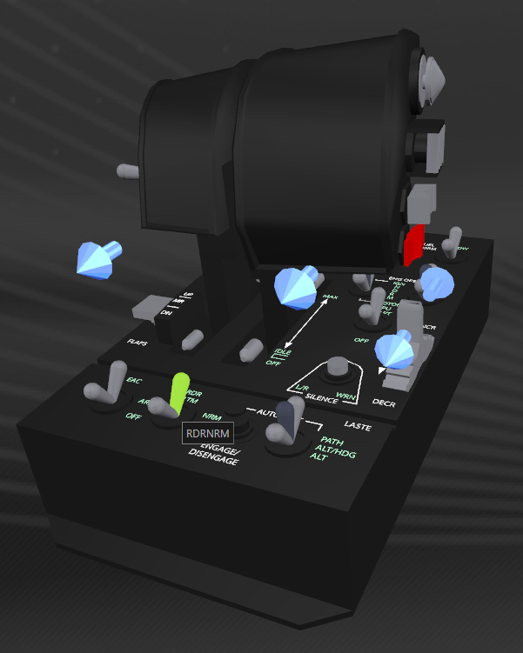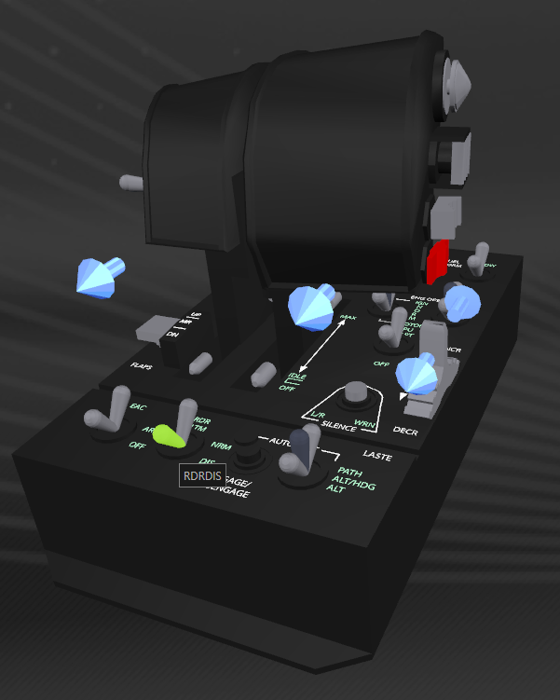

Throttle RDRNRM (Radar Altimeter – NRM) Throttle RDRDIS (Radar Altimeter – DIS)

Cargo Scoop: Status LED 4

Jettison Cargo: Jettisons all cargo in cargo hold. Using both S3+PSF when flicking RDRNRM is about as safe as I can make this!

(… Throttle BASE continued)

Switch Usage Action

APENG-I S3+APENG Enter Hanger and go to Hanger Services

APENG-O APENG Request docking permission  
 (NAV/Target Panel must be in home position or this will not work)

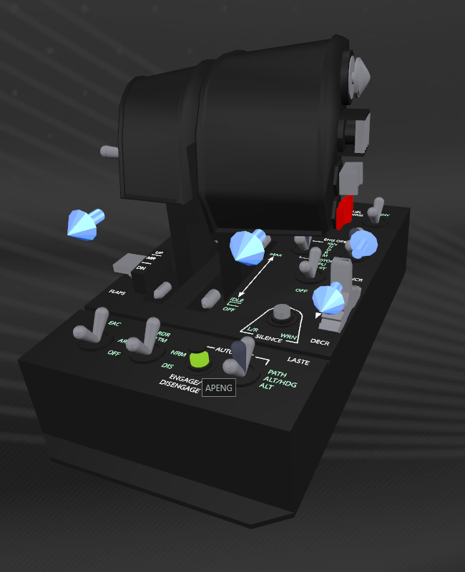  
Throttle APENG (Autopilot Engage Button)

Request docking macro fires a sequence of keystrokes to request docking then returns the selector back to the ‘home position’ in the NAV panel.

When you move within the panels manually, there is no tracking mechanism and my code will not know if we are starting from the ‘home’ position.

If the NAV panel is not at the ‘home position’ when you hit this switch, unpredictable results will happen…USE WITH CAUTION!

The docking request macro will also set 4x PIPs to SYS and 2x PIPs to ENG. If ‘AutoGearDOWN’ is set in ED_UserSettings the landing gear will deploy automatically.

The script also detects when you touch down and will balance PIPs one second after you touch down.

If ‘AutoGearUP’ is set in ED_UserSettings, the landing gear will automatically retract when you lift off.

(… Throttle BASE continued)

Switch Usage Action

LDGH-I S3+LDGH Clear all chat box windows

LDGH-O LDGH Clear currently selected Chat box

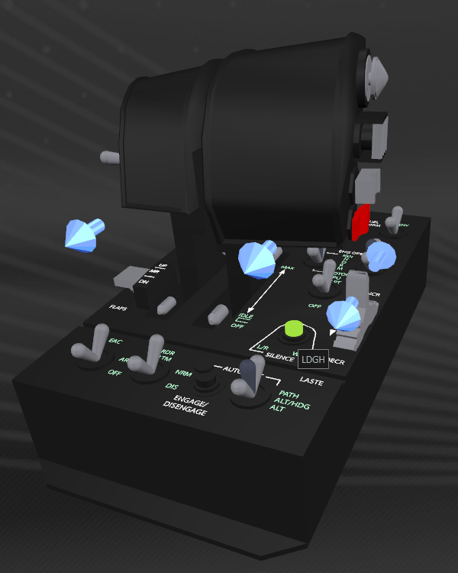

Throttle LDGH (Landing Gear Horn Silence Button)

The ‘clear chat box’ macros send the following key sequence to the selected chat box;

enter, /, c, l, e, a, r, enter

NOTE:   
As written, the Clear all Chat box windows macro will clear both chat boxes.

If you are a member of a squadron, there will be 3x chat boxes.   
Look for the ‘ClearAllChatBox’ macro in EDMacros.tmh file and remove the comments (“//”) from the third sequence.

(… Throttle BASE continued)

Switch Usage Action

FLAPU-U PSF+FLAPU Increase Text-To-Speech Volume

FLAPU-M FLAPU Go to Galaxy Map

FLAPU-D PSB+FLAPU Increase Throttle LED Brightness (0 🡪 5 🡪 0)

Switch Usage Action

FLAPD-U PSF+FLAPD Decrease Text-To-Speech Volume

FLAPD-M FLAPD Go to System Map

FLAPD-D PSB+FLAPD Turn Throttle LEDs OFF  
FLAPDR-D PSB+FLAPDR Turn Throttle LEDs back ON

Increase and decrease Text-To-Speech Volume changes volume of the Voice feedback in increments of 5%. Example: To lower the volume by 10%, use PSF+FLAPD twice. (Lowest volume = 5%)

Turn LEDs OFF by PSB+FLAPD. If you move the PSF modifier switch back to its default PSM position then move the Flaps switch back to M, the LEDs stay off.

To turn them back on, simply toggle PSB+FLAPD and back to middle.

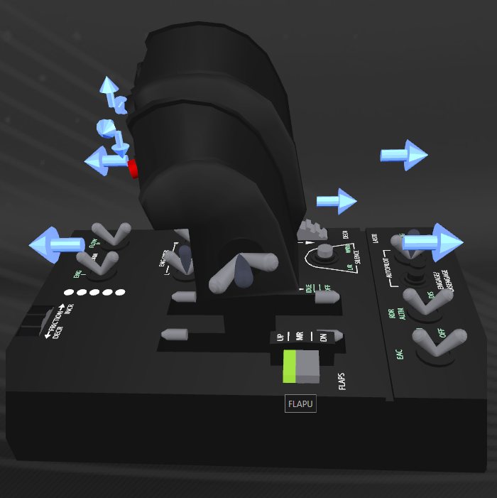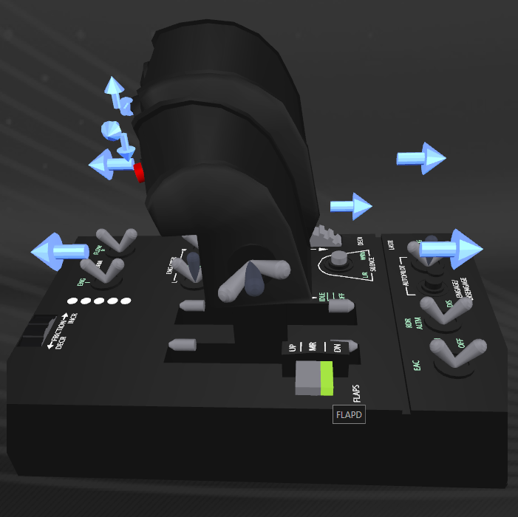  
Throttle FLAPU (Flaps UP) Throttle FLAPD (Flaps Down)

(… Throttle BASE continued)

Switch Usage Action

APUON APUON Deploy SRV  
 ROLE Panel must be in home position or this will not work

APUOFF APUOFF Recover SRV  
 ROLE Panel must be in home position or this will not work

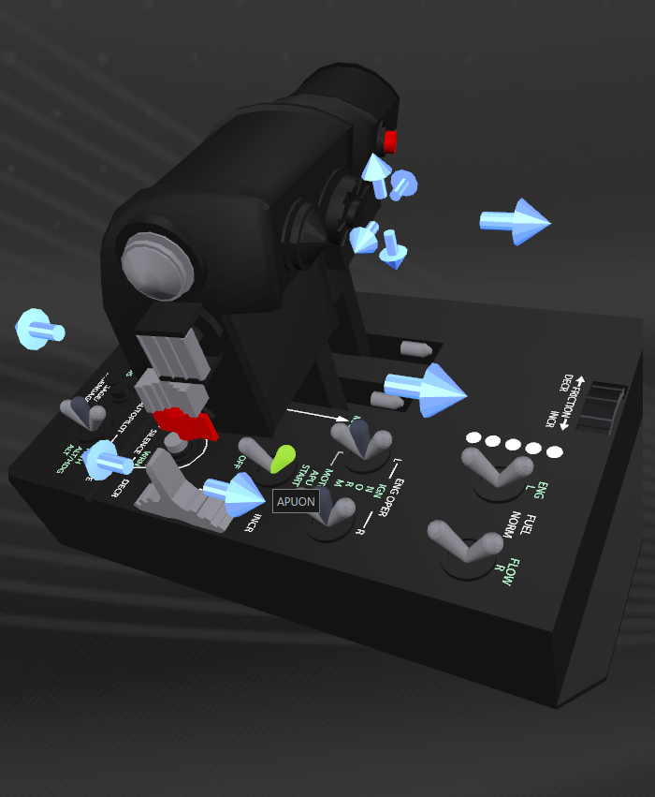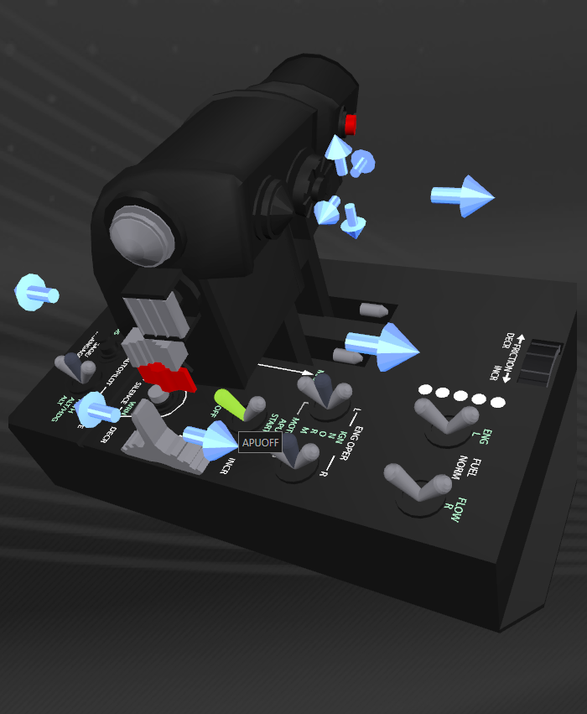

Throttle APUON (Aux Power Unit – START) Throttle APUOFF (Aux Power Unit – OFF)

DEPLOY SRV:  
The script cannot check the presence of an SRV.   
If you use this function with no SRV, unpredictable results will happen.  
The ROLE Panel (lower panel) must be in the Home position for this macro to work.  
The script checks that you are landed, however, make sure you have an SRV!

RECOVER SRV:  
The script cannot currently detect when you are directly under the ship (‘boarding light’ on).  
It will check when the turret is stowed (which means you are close).  
If you use this function when not directly under the ship, unpredictable results will happen.  
The ROLE Panel (lower panel) must be in the Home position for this macro to work.  
Make sure the ‘Boarding Light’ is lit before flicking the APUOFF switch.

WARNING:  
I’ve seen some unpredictable behaviour in the RECOVER macro at times and am yet to make this macro 100% reliable.

This script macro positions the selector but does not send ‘enter’ in case it is not at the correct menu option.

(… Throttle BASE continued)

Switch Usage Action

EORIGN EORIGN Dismiss/Recall Ship (momentary action)

EORMOTOR EORMOTOR Toggle Ship GUI OFF/ON

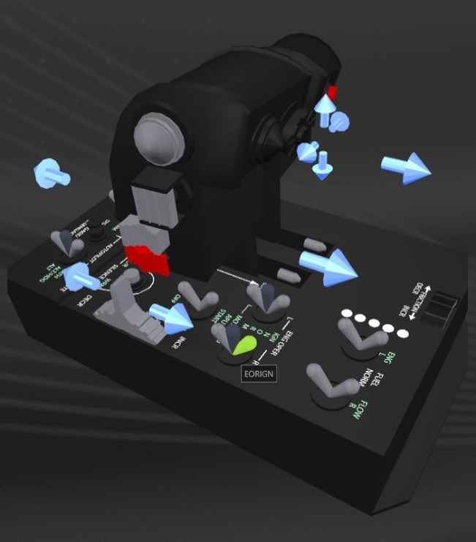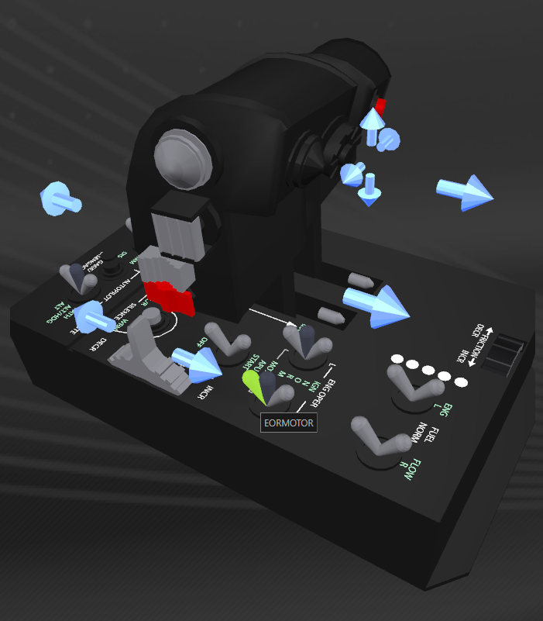  
 Throttle EORIGN (Engine Operate – IGNITION) Throttle EORMOTOR (Engine Operate – MOTOR)

Dismiss/Recall Ship:

This function is only useful if you are not planning to stray too far away from your landed ship, or if you are in the habit of dismissing your ship every time you deploy the SRV.

The Flags key value in status.json does not have a bit representing if the Ship is landed nearby or if it was dismissed. I have implemented my own status variable for this, however if you manually dismiss the ship via keyboard or mouse interaction, or if the ship flies off after you wander far enough away, this variable will not be able to be tracked.

This results in the voice feedback potentially being wrong.  
(I have turned off voice feedback for this function for now, however the code still exists.)

(… Throttle BASE continued)

Switch Usage Action

EOLIGN-U PSF+EOLIGN Game Mode Switch to OPEN

EOLIGN-M EOLIGN Game Mode Switch to PRIVATE GROUP

EOLIGN-D PSB+EOLIGN Game Mode Switch to SOLO

Switch Usage Action

EOLMOTOR EOLMOTOR Toggle Engine and Weapon Colours

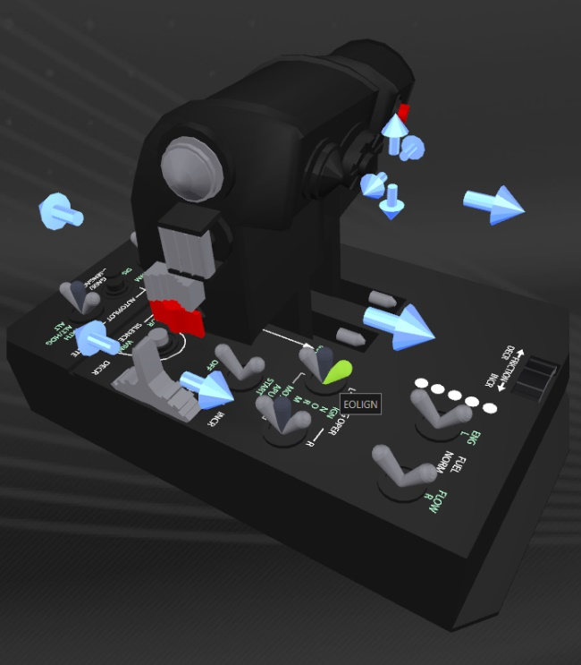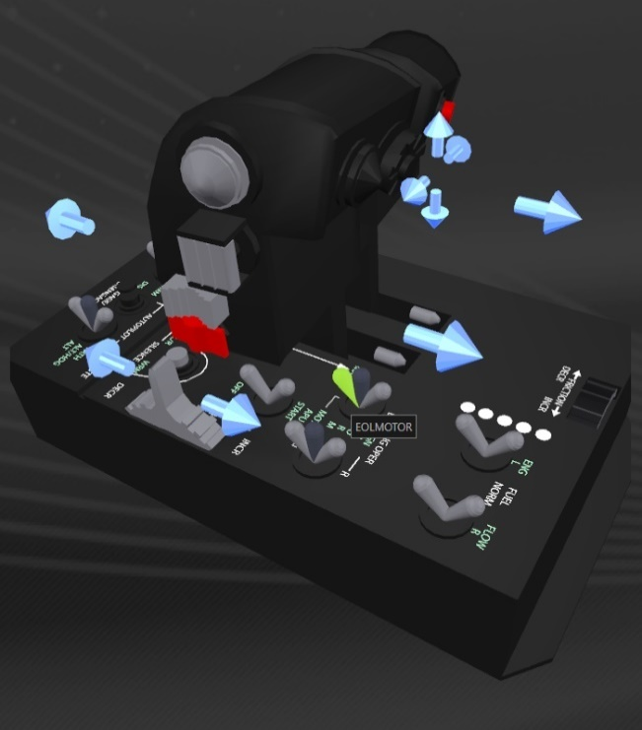  
 Throttle EOLIGN (Engine Operate – IGNITION) Throttle EOLMOTOR (Engine Operate – MOTOR)

Game Mode Switch:  
This macro exits the game to the main menu and logs back in to which ever mode you selected via the PSF/PSM/PSB switch.

The script checks for and sets various ship systems that are reset as part of a Menu log or game restart.

These include the Cargo Scoop, Reverse Thrust and Silent Running.  
Last time I checked, FA-OFF and the condition of the lights, are not reset.

**NOTE**: This Mode Switching macro will not fire if you are in danger (ie Combat) and so cannot be used to Combat Log (clog) on your opponent.

(… Throttle BASE continued)

Switch Usage Action

EFRNORM-U PSF+EFRNORM Debug tool: Dump Flags to console (see note below)

EFRNORM-M EFRNORM Debug tool: Reset Status LEDs (see note below)

EFRNORM-D PSB+EFRNORM Debug tool: Print Status Page banner to console

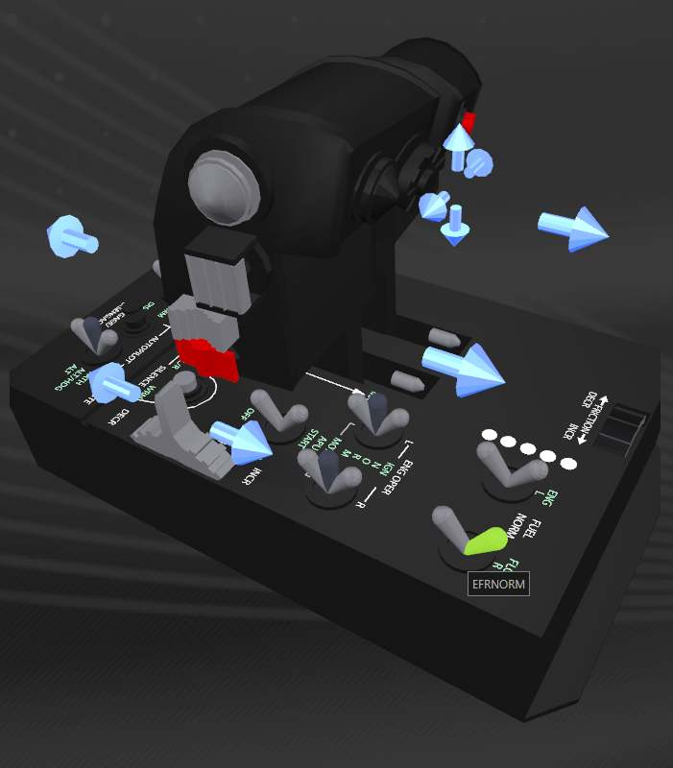  
Throttle EFRNORM (Fuel Flow Right – NORMAL)

**Dump Flags to Console:**

Will print out all currently *set* ‘Flags’ and ‘Flags2’ bits from status.json to the console.

**Reset Status LEDs:**

If the Status LEDs are toggled in quick succession, they can occasionally go out of synch. Using EFRNORM will force the script to align the LEDs to the values of status.json ‘Flags’ bits.

LED Status LED on flag bit variable

LED1 Flight Assist OFF fFAOff  
LED2 Ship/SRV Lights ON fLights  
LED3 Silent Running ON fSilentRunning  
LED4 Cargo Scoop DEPLOYED fCargoScoop  
LED5 Landing Gear DEPLOYED fLandingGear

(… Throttle BASE continued)

Switch Usage Action

EFLNORM-U PSF+EFLNORM Debug Tool: Turn ‘ShowFlags = ON’

EFLNORM-M EFLNORM Debug Tool: Turn ‘Debug = ON’

EFLNORM-D PSB+EFLNORM Debug Tool: Turn ‘Debug’ and ‘ShowFlags’ = ON

EFLOVER EFLOVER Debug Tool: Turn ‘Debug’ and ‘ShowFlags’ = OFF

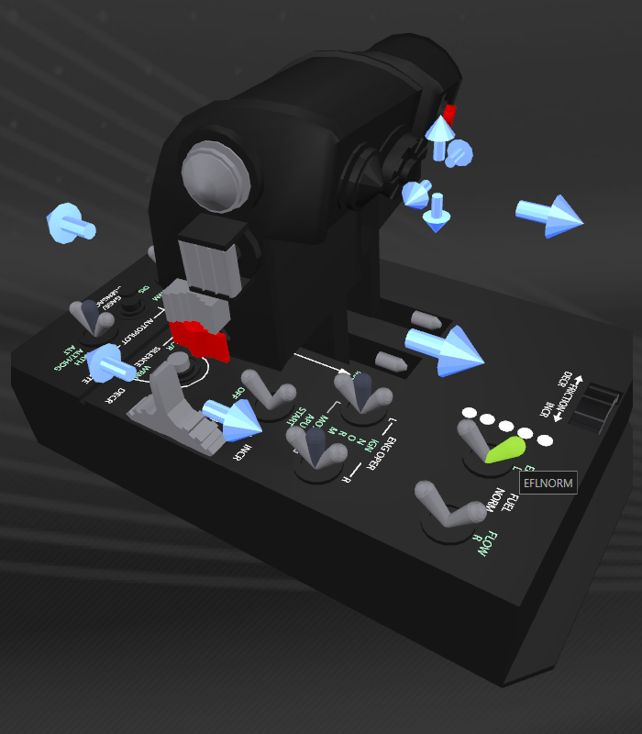  
Throttle EFLNORM (Fuel Flow Left – NORMAL)

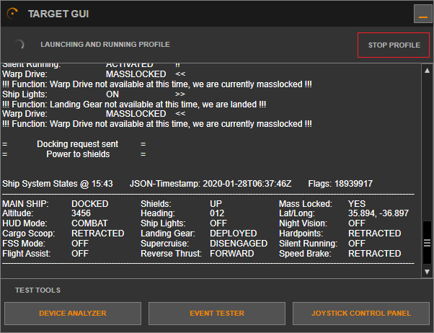  
Example of Status Page

(… Throttle BASE continued)

Switch Usage Action

IDLELON IDLELON Ship: Enter Hanger and Station Services  
 SRV: Toggle hand brake on

IDLELOFF IDLEOFF Ship: Exit Hanger and Lift off (retract landing gear)  
 SRV: Toggle hand brake off

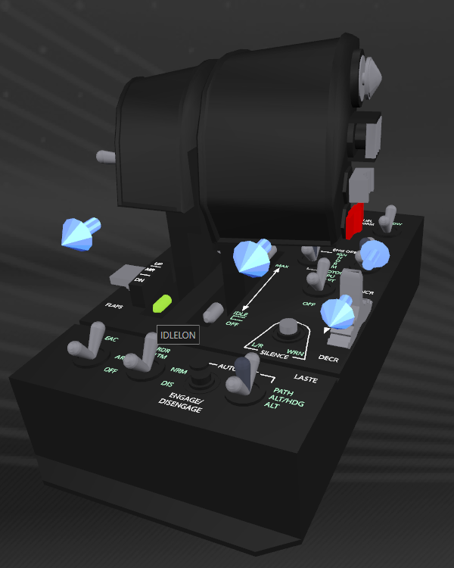  
Throttle IDLELON (Engine Idle – LEFT)

**Engine Idle ON LEFT/RIGHT:**

To engage Engine Idle Switch, from the Throttle all the way back position, LIFT and move back over the notch.

**Engine Idle OFF LEFT/RIGHT:**

From the Engine Idle ON position (lifted + all the way back), move the Throttle lever forward until it drops back off the notch.

# TFRP Rudder Controller

The rudder pedals provide yaw for the ship and steering for the SRV.

Curves may be applied to the rudder via the autopilot switch and can be customised within the ED_UserSettings.tmh file.

Curves are turned off by flicking the Autopilot switch to the ‘ALT/HDG’ position (APAH).

These curves are linked to the Joystick curve profile.   
Refer to the ‘Axis Curves and Curve Control’ section.

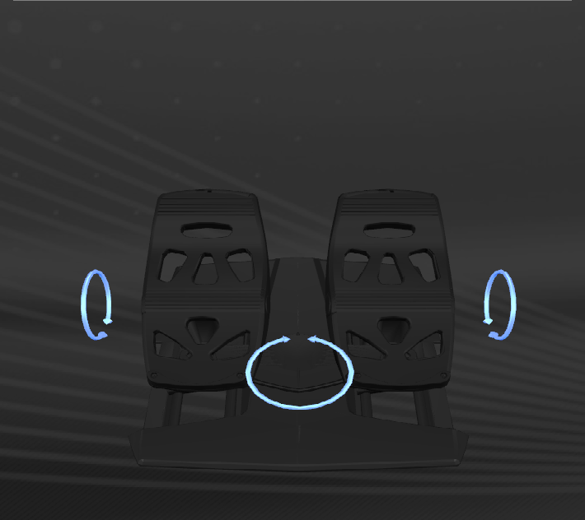  
TFRP Rudder Pedals

**Note:**

The Toe Brakes are not currently mapped in this script.

# Keyboard Key Binds

Notable keys (generally no script function mapped):

Key Label Action

RSHIFT+W RollLeft Alternate Roll Control – Left (mapped if no rudders)

RSHIFT+S RollRight Alternate Roll Control – Right (mapped if no rudders)

RSHIFT+Q YawLeft Alternate Yaw Control – Left (mapped if no rudders)

RSHIFT+E YawRight Alternate Yaw Control – Right (mapped if no rudders)

NP-3 SetSpeed75 Sets Throttle to 75% (Blue Zone)

X SetSpeed0 Set Throttle to 0 (or SRV Handbrake)

NP-Enter SwapRollYaw Swaps Roll axis and Yaw Axis (Mapped to S1-D)

LALT+B FighterDock Send Dock order to fighter

LALT+D FighterDefend Send Defend order to fighter

LALT+A FighterAggr Send Aggressive order to fighter

LALT+T FighterAttack Send Attack order to fighter (focus on my target)

LALT+H FighterNoFire Send Hold fire order to fighter

LALT+S FighterHold Send hold position order to fighter

LALT+F FighterFollow Send follow me order to fighter

LALT+O FighterOpen Send open orders to fighter

LALT+W WeaponColour Swaps Weapon Colour On/Off

LALT+E EngineColour Swaps Weapon Colour On/Off

RALT+F11 GalNetPlay Toggle Play/Pause GalNet Audio

RALT+F10 GalNetPrev Select previous GalNet item to play

RALT+F12 GalNetNext Select next GalNet item to play

RALT+F9 GalNetClear Clear the GalNet Audio Queue

LCTRL+1-9 CameraPreset1-9 Cycle Camera pre-sets

**Note:**

Multi crew key binds are not currently used in this script nor mapped in the bind files

Fighter commands are not currently used in the script, however these are present in the bind files

(… Keyboard Keybinds continued)

Full Keybind Listing Refer to following files;

File Location

ED_Defines.ttm Script folder

KeyBinds.xls Maps folder

Keyboard Usage.png Maps folder

…or the below pages;

Joystick Map – BASIC and FULL

Throttle Map – BASIC and FULL

Key Bind Sheet

# ED_UserSettings File

**Variable Default Use**

MapKeyProfile FULL Use all macros and functions

FlashLEDs ENABLED Enables flashing base LEDs at startup and status LEDs when status changes

LEDLevel 1 Sets the LED brightness level on the Throttle base (0 – 5)

StatusFile <string> Pathname for Elite Dangerous ‘status.json’ file

StatusReadRate 500 Loop timer (in msec) that the script will read status.json

MyStatusFile <string> Pathname for extra state flags to be saved (Refer to chapter on “Special Functions” later in this guide)

EnableVoice ENABLED Enables the TextToSpeech engine (voice feedback)

VoicePath <string> Pathname to ‘voice.exe’

VoiceVolume 75 Default volume for TextToSpeech Voice

“TTS Voice name” <alias> Short name for TTS Voices installed and enabled on your PC

DefaultVoice <alias> Set to your preferred (installed) MS TTS Voice

VoiceCMD <string> Command line options for voice.exe

TrainingMode ENABLED Enables ‘training mode’. When game is not running,  
 pressing a button or switch will announce what it does via voice feedback and console printout

AnnounceTraining ENABLED Announces if Training Mode is available/active

EnableSoundFX ENABLED Enables the SoundFX Engine (.wav file player)

SoundPath <string> Pathname to ‘sounder.exe’

WAVPath <string> Pathname to wav files for SoundFX

SoundCMD <string> Command line options for sounder.exe

DefaultPIPMode 3 Select your choice of 6 PIPModes as the default

PulseTime 33 Key press (hold down) time (in msec)

DelayTime 75 Delay between releasing one key and press the next (msec)

LongPress 500 Used for ‘TEMPO’ delay (msec). Hold key for ‘LongPress’ to trigger second action

DiscoDelay 6100 Trigger mode for Discovery Scanner. Holds trigger for ‘DiscoDelay’ milliseconds then releases (6.1 seconds)

(… Ed_UserSettings File continued)

AutoHanger DISABLED When enabled will enter hanger and select station services automatically when you dock

AutoHUD DISABLED Enable to automatically engage Analysis Mode when going into super cruise

AutoGearUP DISABLED Raises Landing Gear automatically when you lift off

AutoGearDOWN DISABLED Lowers the Landing gear when you request docking perm

AutoHeatsink ENABLED Fire a heatsink when temperature hits 100%

AutoStrobe ENABLED Enable to strobe silent running on and off every 2 second when shields drop and ‘in-danger’. Handy to break target lock on pursuing ships

CommsModule DISABLED Future feature – currently in test

ChatTABs 3 Set to number of Chat TABs you have within the Comms Panel. Reqd for fnClearChatBox() function

Joystick_* * Joystick dead zone and zoom settings (for curves)

Rudder_* * Rudder dead zone and zoom settings (for curves)

Slew_* * Slew control dead zone and zoom (for curves)

FAOFFCurves SLOW Set your desired curve profile when you go FA-OFF

CurveInfo NOPRINT Will print curve profile settings to console if = PRINT

EnableTFRPRudder 1 Set this to ‘0’ if you do not have these rudder pedals  
 Alternate Roll and Yaw will then be available via Mike Switch

SwapRoll4Yaw 0 Set to 1 to swap the Roll and Yaw axes on Joystick/Rudder

Joystick_Curve[] * Joystick Curve array settings (0 - 4)

Rudder_Curve[] * Rudder Curve array settings (0 - 4)

Slew_Curve[] * Slew Curve array settings (0 or 2)

# Joystick Map - FULL

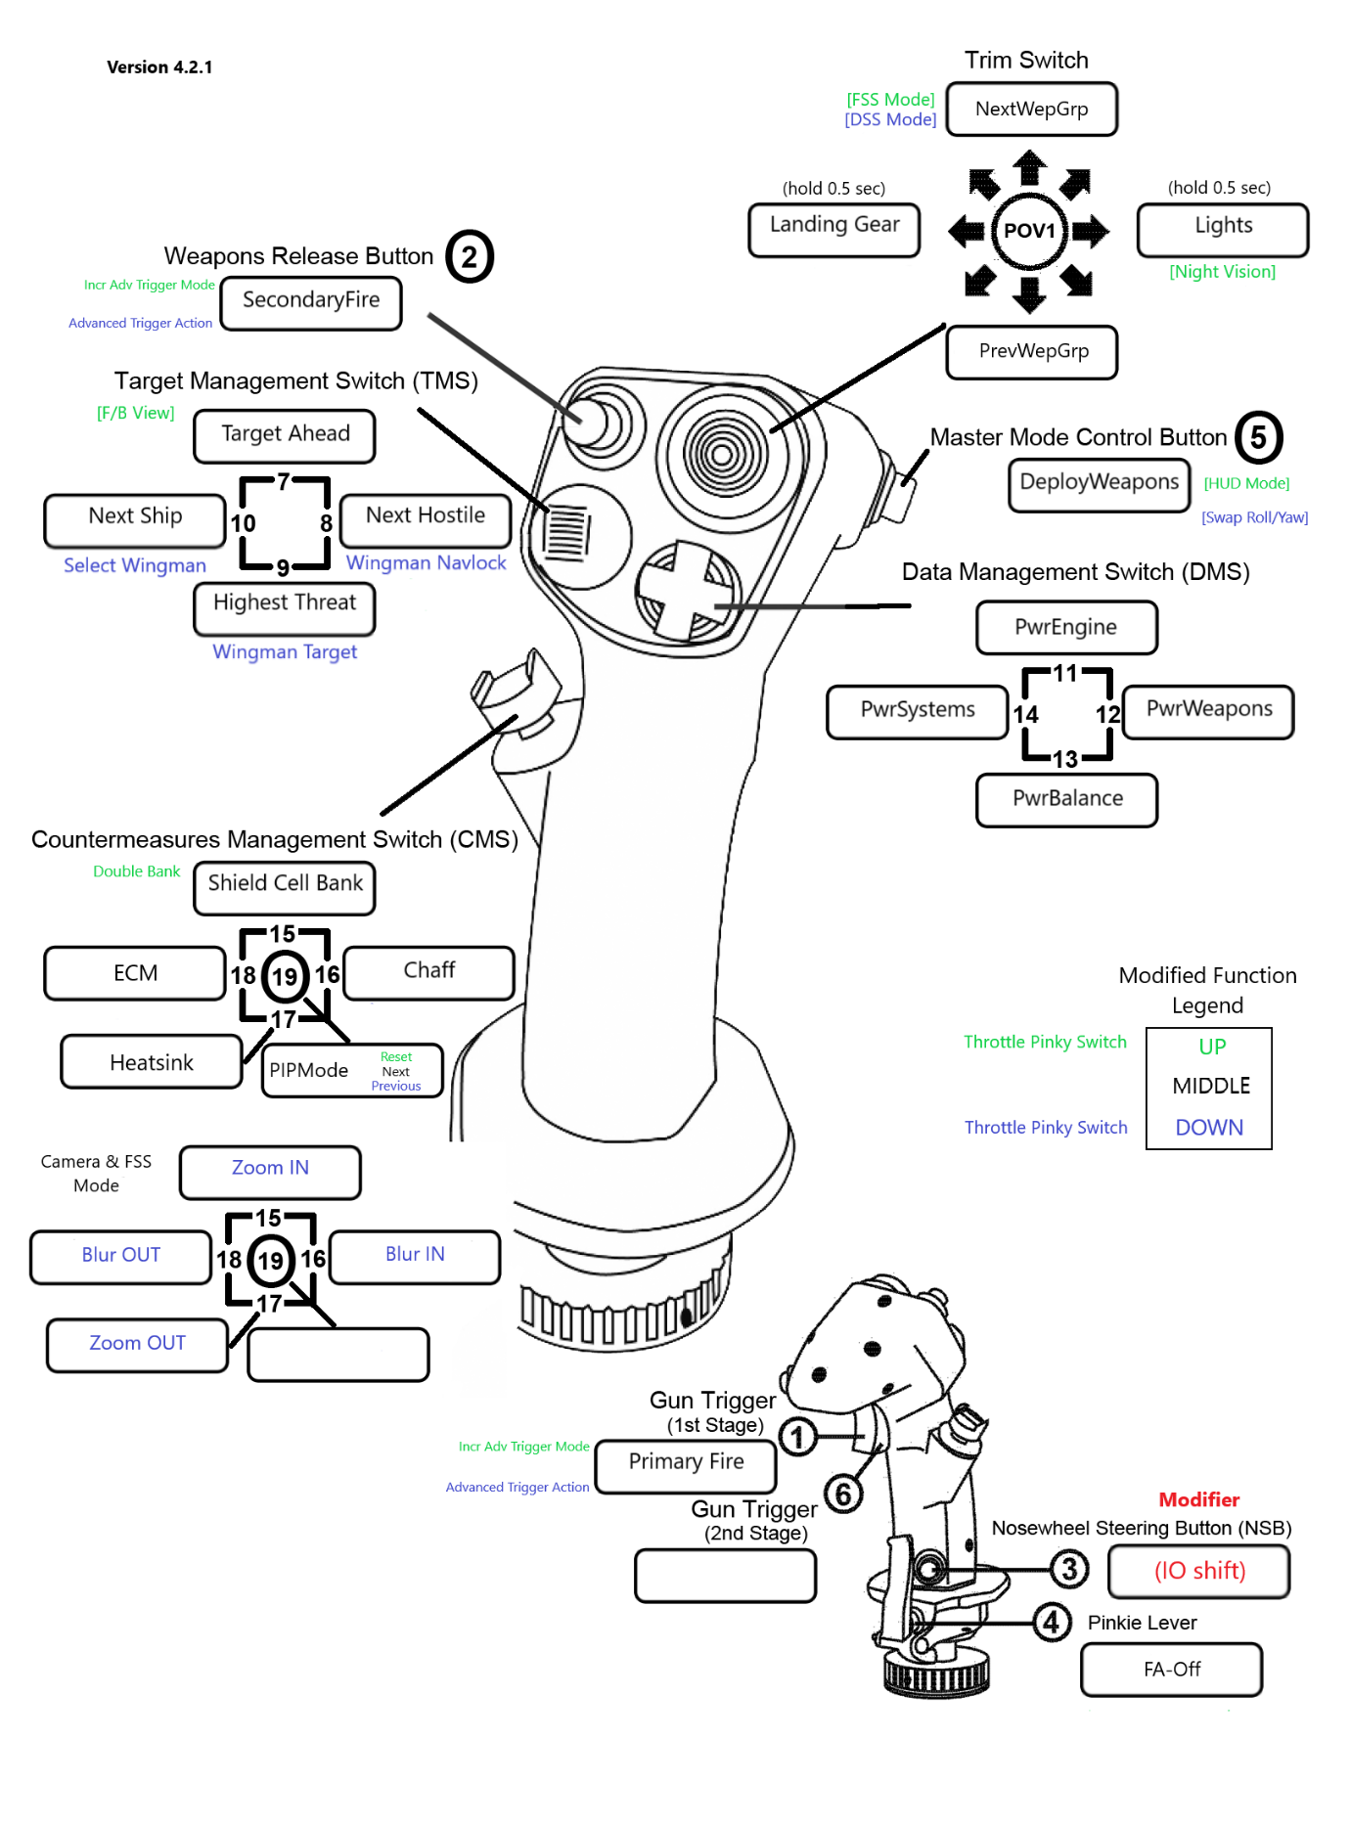

# Throttle Map - FULL

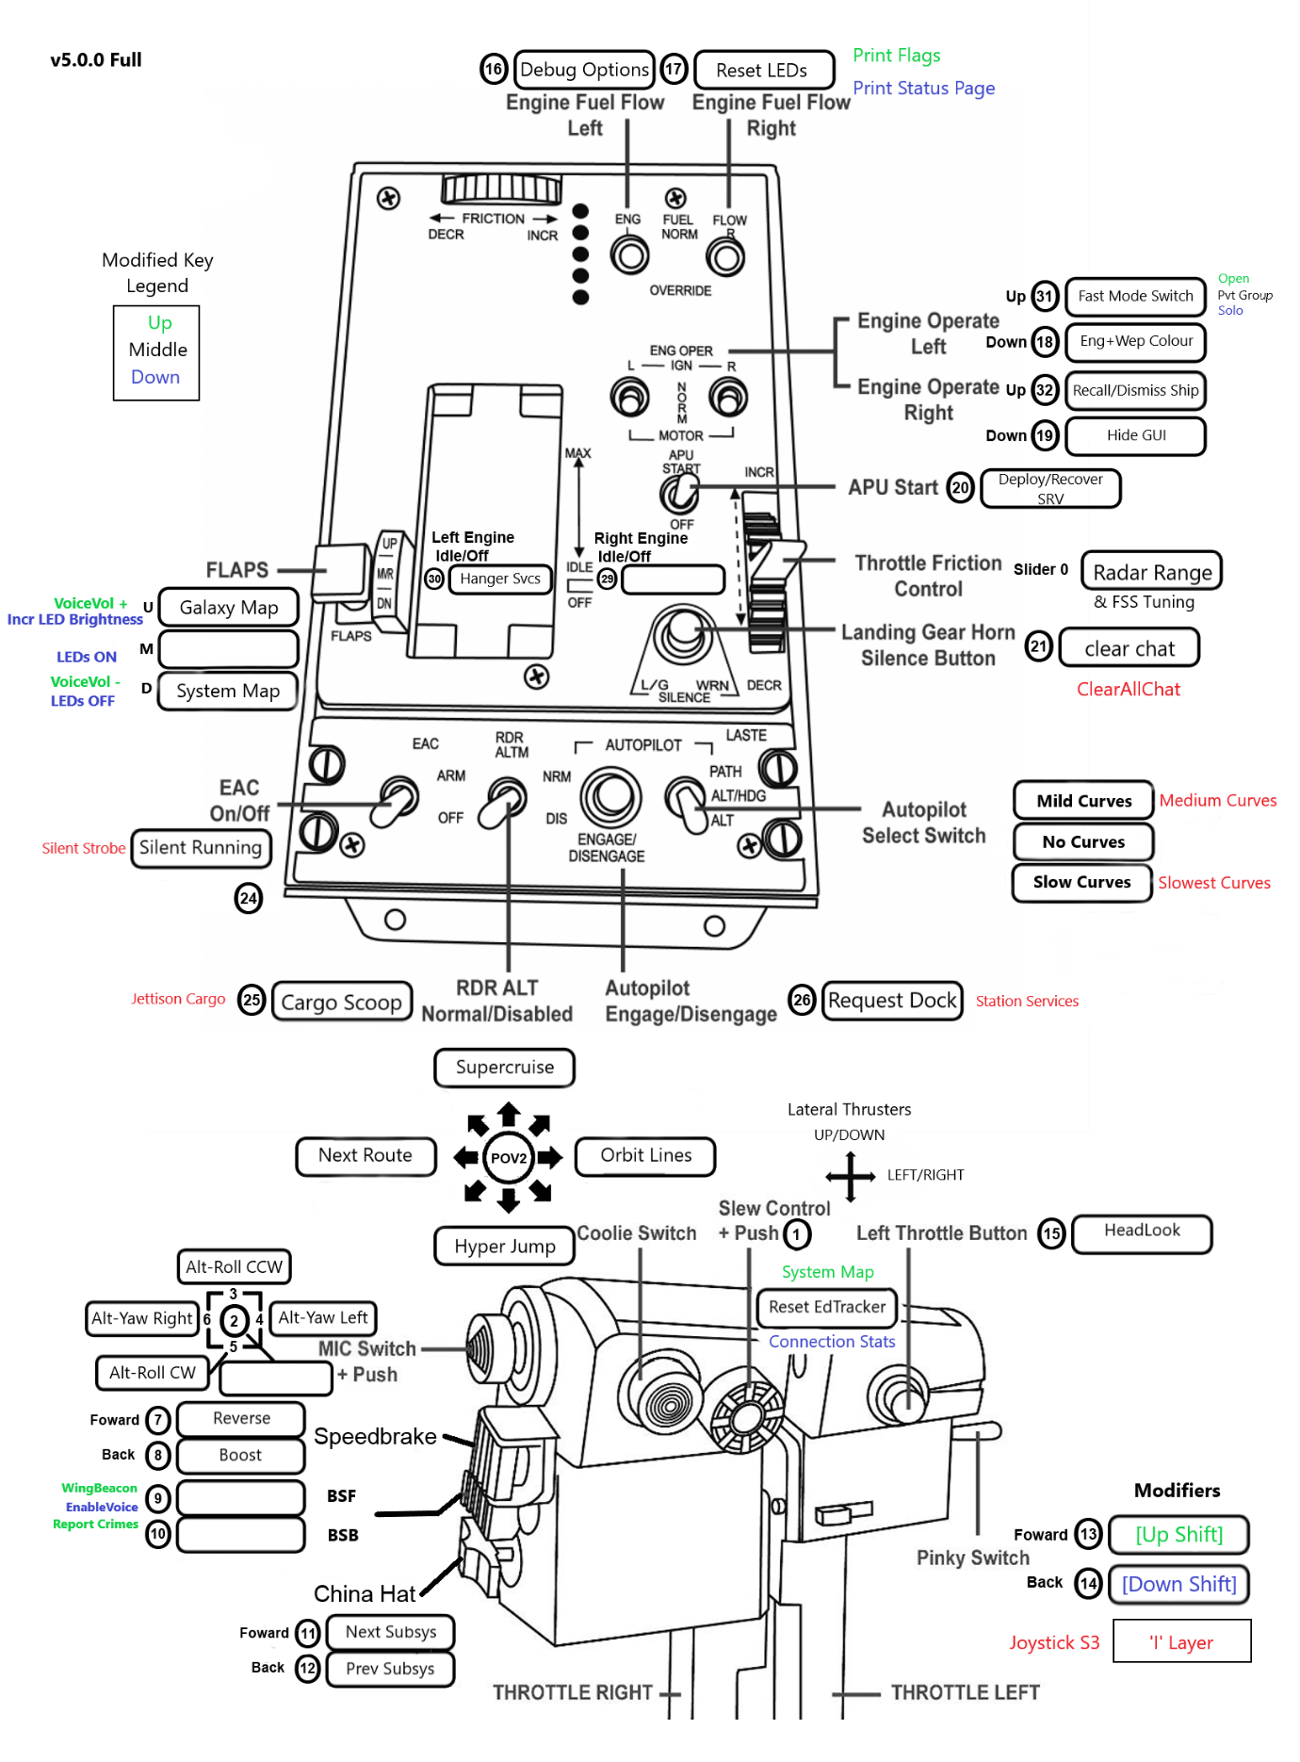

# Joystick Map – BASIC

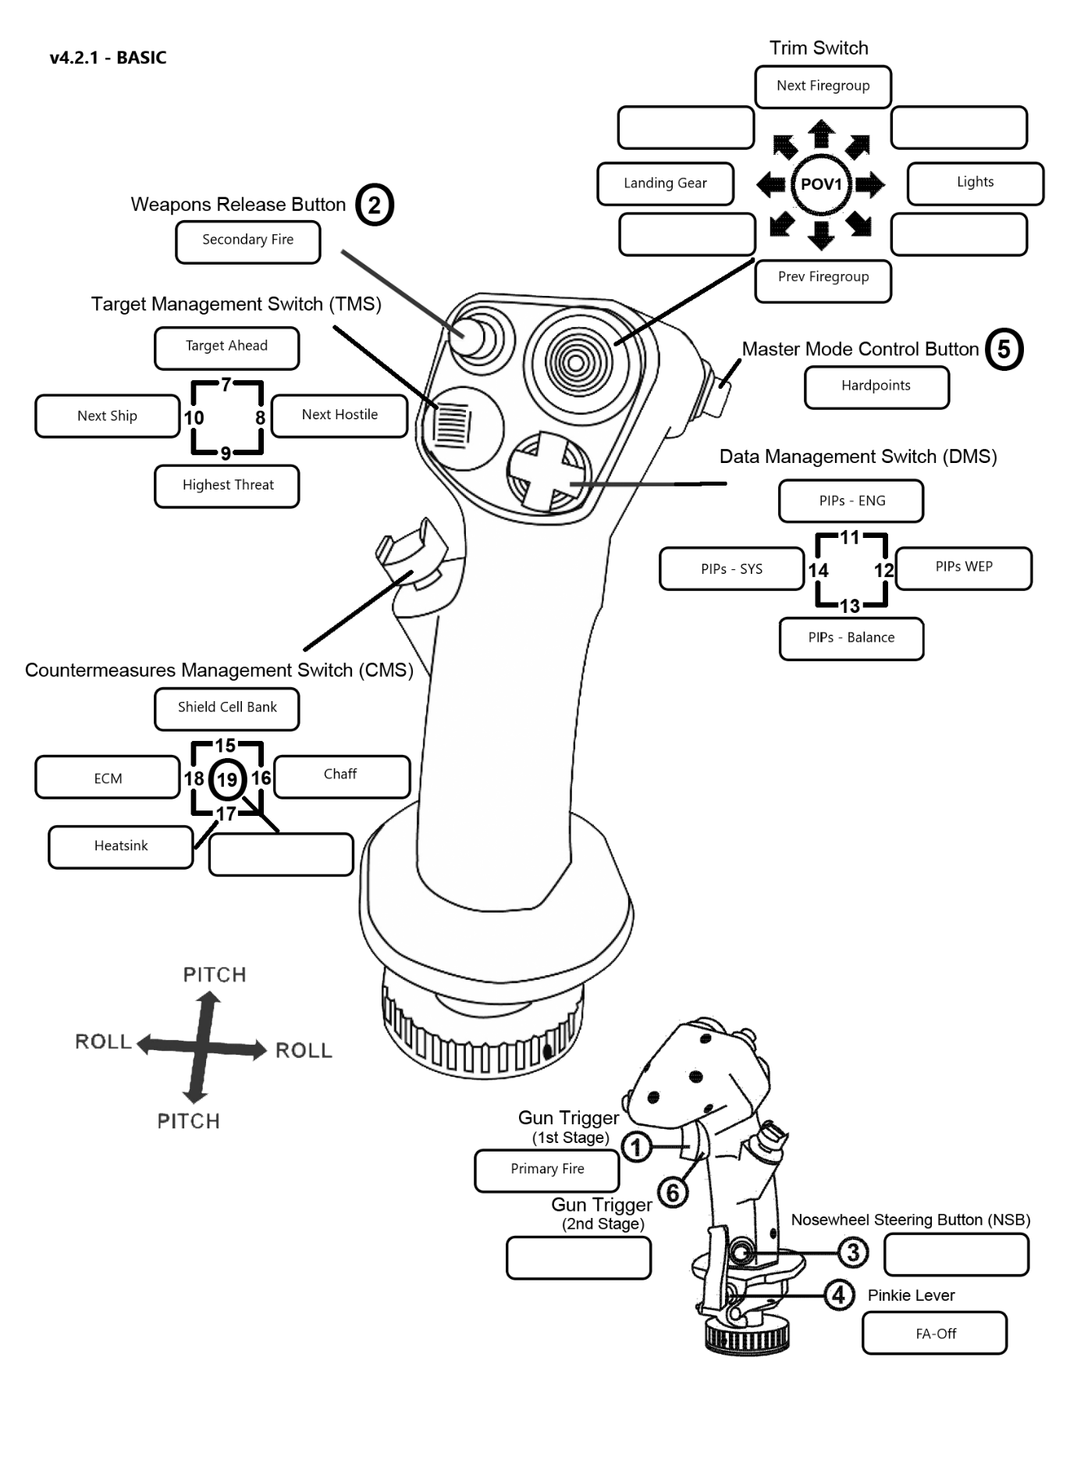

# Throttle Map – BASIC

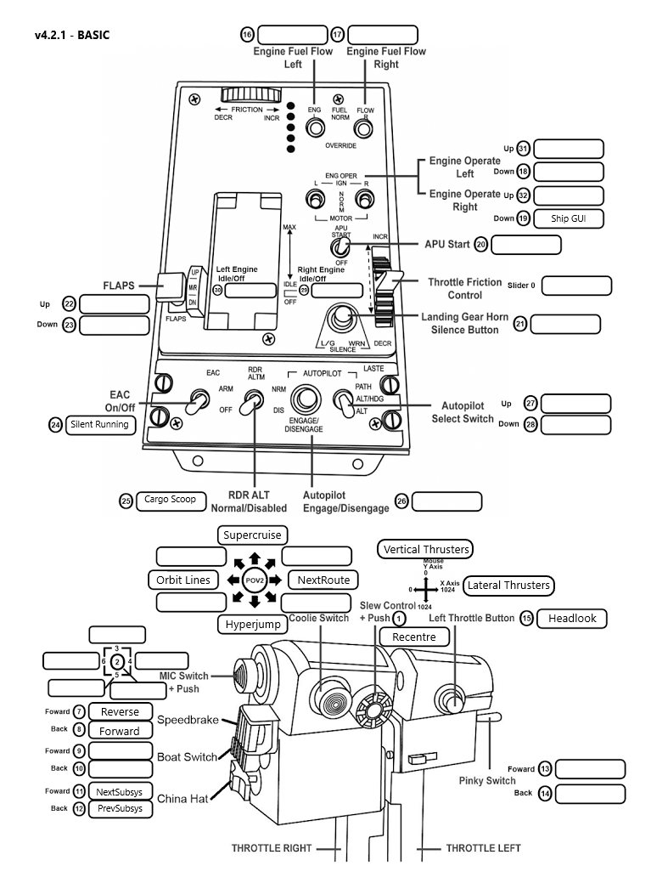

# Keyboard Utilisation

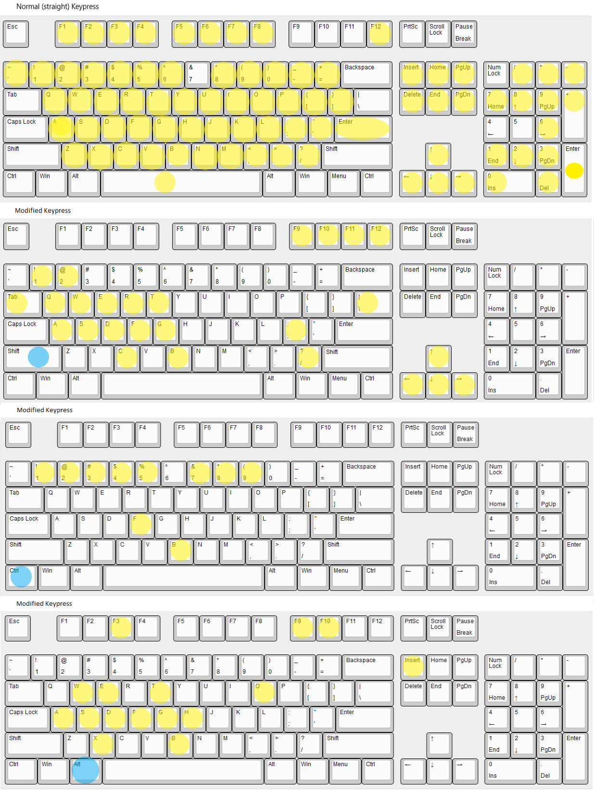

# Key Bind Sheet – In Ship/SRV/Fighter



# Key Bind Sheet – On Foot



# HOTAS Switch and Button Reference – FULL



# HOTAS Switch and Button Reference – BASIC



# Disclaimer

This software is a work in progress.

No warranties are stated or implied and no responsibility will be accepted for any damage this software may cause to your hardware, sanity or marital status.

By downloading, installing and using this software, you agree this is at your own risk.